HEALTH AND MEDICATION ADMINISTRATION MANUAL
FOR PERSONS WITH INTELLECTUAL/DEVELOPMENTAL DISABILITIES

A STUDY GUIDE AND REFERENCE MANUAL
Section 3-A, Appendix 2024

Contents
- Appendix 1. INTRODUCTION – DEFINITIONS 4
- Appendix 2. THE ROLE OF THE CAREGIVER 20
A. duties A CAREGIVER MAY BE EXPECTED TO PERFORM 20
1. MEASURING INTAKE AND OUTPUT (I&O) 20
2. COLLECTION OF URINE SPECIMENS: 21
3. URINARY CATHETER CARE: 22
4. ORAL SUCTIONING: 26
5. ASSISTING WITH COMPRESSION HOSE (stockings): 27
- Appendix 3. GENERAL INFORMATION 29
A. CONTROLLED SUBSTANCES 29
B. STORAGE OF MEDICATIONS 29
C. SPECIAL CIRCUMSTANCES 30
1. Sun Sensitivity: 30
2. Changes in color of urine: 30
D. off-site and home medications 31
E. GUIDELINES FOR WRITING PROTOCOLS 31
1. PRN PROTOCOLS 31
2. SEIZURE PROTOCOLS: 34
3. EATING PROTOCOLS: 35
4. DIABETES MONITORING: 36
- Appendix 4. medication forms & administration 37
A. ORAL MEDICATIONS 37
B. Rectal medications: 37
C. Vaginal medications: 38
D. More information on Oxygen therapy 38
- Appendix 5. ADMINISTRATION OF MEDICATIONS 41
A. WHAT MUST You KNOW ABOUT A MEDICATION 41
B. standard precautions 42
C. PHARMACY LABELS 43
D. preparation of medications 43
E. administration of medications – procedures: 44
E1. SUBLINGUAL OR BUCCAL MEDICATIONS 44
E2. Topical medications: 46
skin creams or ointments 46
E3. transdermal medication 46
E4. eye medication 47
E5. ear (otic) medications 48
E6. nose (nasal) medications 48
E7. rectal medications 49
E8. vaginal medications 52
E9. inhaled medications 53
- Appendix 6. DOCUMENTATION 56
A. tHE MEDICAL RECORD 56
B. The Medication Administration Record (MAR) 56
- Appendix 7. FILLING OUT THE MAR 57
A. Examples of filling out a mar 57
B. use of the optional “dot system” 64
- Appendix 8. MEDICATION ERRORS 65
C. When a Medication is TAKEN BY the wrong person, WHICH MEDICATIONS REQUIRE CLOSER MONITORING? 65
- Appendix 9. TYPES/CATEGORIES OF MEDICATIONS 69
A. anti-infective medications 69
- Appendix 10. MEDICATIONS FOR PSYCHIATRIC CONDITIONS 72
A. DEPRESSION AND ANTIDEPRESSANTS 72
B. antipsychotic agents 74
- Appendix 11. SEIZURE DISORDERS 76
A. Side effects of anti-seizure medications 77
B. PRN Treatment for Seizures/Status Epilepticus 79
C. Deaths related to epilepsy 85
- Appendix 12. STROKES 87
A. strokes 87
B. Prevention 87
C. Risk factors 87

Appendix 1. INTRODUCTION – DEFINITIONS
Abdomen: located between the chest and the pelvis; the belly.
Acute: of rapid onset. Often with severe symptoms lasting for only days.
Accessible: available, easily reached or obtained.
Adequate: satisfactory; good enough.
Administer: to give something to someone (ex. gives medications).
Advanced Practice Nurse Practitioner (APRN): a person who is currently licensed as a registered nurse, has completed additional training, and is approved by the Montana Board of Nursing as a nurse practitioner. Nurse practitioners can practice independently.
Agonist: a term used to describe a type of drug that binds and alters activity of a cell receptor which may increase or decrease the receptor’s activity.
Akathisia: a common side effect associated with the use of anti-psychotic medications. It is characterized by the sense of restlessness often accompanied by excessive, usually repetitive, movements such as pacing, foot tapping, or rocking. There is a feeling of inability to sit still as well as anxiety and nervousness.
Anaphylaxis: severe allergic reaction; can cause death.
Aneurysm: when a blood vessel has a weakness of the wall which then balloons out and ruptures.
Anorexia: loss of appetite.
Anoxia: low oxygen levels.
Anticonvulsant (anti-epileptic): a drug used to prevent or reduce the frequency of seizures.
Aphasia: loss of ability to understand or express speech.
Apply: to place one thing on to another (ex. put a band aide on a wound; put ointment onto the skin).
Assemble: to gather up items for completing a task.

Assist: to give support or aid in the self-administration of medications.
Assure: to inform; to remove doubt.
Ataxia: loss of ability to coordinate muscular movement. In general, it means unsteady movements and a staggering walk.
Aura: a peculiar feeling, smell, sound, taste, or other sensation that frequently precedes the onset of a focal seizure. (ex. nausea, headache, unpleasant taste, visions).
Automatisms: repetitive, rhythmic, purposeful movement (such as lip-smacking, swallowing, walking aimlessly, or picking at one’s clothing) that sometimes accompanies a focal seizure.
Autonomic: involuntary or unconscious; relating to the autonomic nervous symptoms.
Autonomic nervous system: a control system that acts largely unconsciously and regulates bodily functions, such as heart rate, digestion, respiratory rate, pupillary response, urination, and sexual arousal.
Benzodiazepines: a class of sedative hypnotic drugs used for anxiety, sedation, muscle relaxation, and seizures.
BiPap (Bi-level Positive Airway Pressure): the pressure provided by the device when breathing in and breathing out are set independently. The expiratory pressure is adjusted to overcome airway obstruction.
Black Box Warning: a warning mandated by the US Food and Drug Administration to appear on the full prescribing information of a prescription medication. These warnings alert prescribers and pharmacists to serious matters regarding the use of a given medication.
Brace/bracing: protective position assumed when in pain or about to get injured; something used to support things.
Bradycardia: abnormally slow heart rate.
Bradykinesia: abnormal slowness of movement such as a shuffling walk. It is the main symptom of Parkinson’s disease.

Brand name (Trade name): the specific name of a product (such as a drug) that can be used only by the company that registers the name.
Bronchodilators: a medication used in the treatment of lung disorders, especially COPD (chronic obstructive pulmonary disease). It works by relaxing and expanding (dilating) the airways making it easier to breath.
Carbohydrate: the chief fuel for the body; found in fruits, vegetables, grains, breads, and sweets.
Cardiomyopathy: chronic disease of the heart muscle causing deterioration of functioning of the heart.
Category (type): grouping together of items with similar features.
Central Nervous System (CNS): the brain and spinal column; the system that carries the impulses (messages) that allow the body to function.
Chronic: a condition that lasts for more than 6 weeks; a condition that gets worse over time or shows little improvement over time (for example: diabetes, arthritis, multiple sclerosis).
Clonic: the phase in a generalized seizure in which the muscles alternately tense and relax.
Cognitive: relating to or involving conscious intellectual activity such as thinking, reasoning, or remembering; the way a person thinks and makes sense out of experiences.
Colostomy: opening into the large intestine (colon).
Competent: able to do a task or job independently.
Confirm: to support; to validate; to establish the accuracy of information.
Confusion: bewilderment; not understanding what is happening; not being able to think clearly.
Congestion: excess blood or fluid in an area of the body such as nose or lungs, which can make it difficult to breath.
Console: to comfort.
Contaminated: dirty; containing impurities or bacteria.

Controlled drug (or substance): a drug that is regulated by law under the Federal Classification System. Drugs found to be habit forming are assigned a schedule from II to V depending on their potential abuse.
Convert: to change; to make into something else.
Convulse: to have a seizure; uncontrolled spastic movements of the body – especially arms, legs, and torso.
CPAP (Continuous Positive Airway Pressure): the device delivers a constant pressure throughout the respiratory cycle to help prevent airway obstruction.
Crucial: most important; necessary.
Deformity: malformed; usually involves a body part such as a missing limb or club foot.
Delegate: to transfer or pass on responsibility to another person.
Delirium: mental confusion which is usually temporary. Disordered speech and hallucinations are often present.
Delusions: false beliefs that are firmly held.
Delusions of grandeur: the false belief that one is famous or publicly important or is a god.
Paranoid delusions: believing that one is being followed, spied upon, secretly listened to, etc.
Dementia: mental deterioration due to organic causes such as peripheral vascular disease (narrowing of blood vessels so less blood gets to brain tissue) or Alzheimer’s.
Demonstrate/demonstration: to show someone how to do a task or job or to show that you know how to do a task or a job.
Depression: an extreme mood of sadness with physical symptoms such as loss of appetite or sleep.
Disintegrate: to fall apart; to break into fragments or small pieces.

Disorientation: loss of one’s sense of direction, position, or relationship with the surroundings. A temporary or permanent state of confusion or not knowing where one is, who one is, or time including season or month.
Dispense: to give out or distribute to another.
Dispose: to get rid of; to throw away.
Dispensing container: package, bottle, or vial of medication that comes from the pharmacy or store.
Dispensing label: the description found on prescribed or OTC medication identifying the name of the drug, the amount, strength, how and when to take the drug.
Documentation: to write down what has happened; to record or write up an event.
Dose: the specific quantity of a drug; the amount of medication to be taken.
Duration: the length of time a medication is to be taken or length of time a medication works.
Dysarthria: slurred or slow speech.
Dyspepsia: indigestion; characterized by pain in the upper abdomen, abdominal fullness, and feeling full earlier than expected when eating.
Dysphagia: difficulty swallowing.
Dysphasia: difficulty expressing speech.
Dysphoric: feeling unwell or unhappy.
Dystonia: muscle spasms.
Dystonic: muscles contract uncontrollable causing the body to twist.
Eczema: inflammation of the skin with reddened patches that drain and become crusted over and scaly.
Elixir: a sweetened preparation of a drug that contains alcohol.
Embolic stroke: a type of stroke that occurs when a blood clot breaks off and is trapped inside an artery causing blockage of blood flow to that section of the brain.

Emotional: something that makes you have a strong feeling.
Emulsion: a mixture of oil and water.
Enteric coated: hard covering on a tablet that prevents it from falling apart in the stomach.
Epilepsy (seizure disorder): a condition in which a person may continue to have seizures throughout his/her life unless controlled by medications or other means. The cause may or may not be known.
Episode: an incident; the display of symptoms or behaviors associated with an underlying condition.
Ethics: the science of moral values; a moral code of conduct that respects confidentiality and privacy.
Exhale: to breath out.
Expiratory: when breathing out.
Exposure: contact with something such as a substance, material, surface, etc.
Extract: a solution or powder obtained by removing and concentrating drug ingredients from a plant or animal.
Extrapyramidal side effects (EPS): a group of symptoms that can occur in persons taking antipsychotic medications. Side effects include tremor, akathisia, slurred speech, dystonia, bradykinesia, muscle rigidity.
Feasible: capable of being done; realistic ability to do something.
Form of medication: having to do with the shape or consistency such as tablet, liquid, etc.
Fracture: to break (example: a broken bone).
Frequency: how often a medication is given (example: once a day, every 8 hours, etc.).
Gait: the way a person walks or moves about on foot.
Gastrostomy: opening into the stomach.
Generic: not a trade name, pertaining to the common active ingredient of a drug such as acetaminophen (the active ingredient of Tylenol®).
Glucagon: hormone used during a low blood sugar emergency. Given by injection or intranasally.
Glucose: sugar.
Glucometer: a device used to check or record someone’s blood sugar.
Hallucinations: the perception of a nonexistent object or event. Hallucinations involve hearing, seeing, feeling, smelling, and even tasting things that are not real.
Auditory hallucinations: hearing voices or other sounds that are not present, are the most common type.
Hay fever: allergic reaction to grasses, pollens, dust, animal dander, and other irritants.
Health care professional: physician, licensed nurse, dentist, nurse practitioner, physician assistant, podiatrist, pharmacist, etc.
Hemorrhoid: dilated vein found inside (internal) or outside (external) the anus.
Hemorrhagic stroke: a sudden onset of neurological symptoms as a result of bleeding inside the brain. Commonly caused by a ruptured blood vessel (aneurysm).
Hormone: a substance secreted in the body for a specific purpose (such as insulin which is needed by the body to use carbohydrates).
Hyper: higher than what is considered normal (hypertension = high blood pressure, hyperglycemia = high blood sugar).
Hypo: lower than what is considered normal (hypoglycemia = low blood sugar).
Idiopathic: unknown cause.
Implement: to start something; to begin a plan or act.
Inappropriate: not consistent with the situation (example: laughing when feeling sad).

Incontinence: spontaneous exit of urine from the bladder; wetting oneself.
Ingest: to take into the mouth and swallow.
Inhale: to breathe in; to take in air.
Initial dose: the first dose of a drug.
Inject: to put a medication into the body by using a sterile needle and syringe.
Insomnia: a symptom of a sleeping disorder characterized by difficulty falling asleep or staying asleep.
Inspiratory: when breathing in.
Instill: to put medication in a body cavity or on a mucous membrane (example: eyedrops are instilled into the eye).
Interaction: two or more drugs reacting together to change their intended effects on the body.
Intramuscular: to give an injection (shot) into a muscle.
Intellectual disability: not being able to comprehend or process information in the same manner as would a person with typical intelligence.
Lancet: a sharp device used to prick the finger to get a drop of blood.
Lapsed: no longer good; no longer current; expired.
Lesion: injury or wound; area of skin that has some sort of alteration.
Lethal dose: a dose likely to cause death.
Lethargy: sluggishness; drowsiness; being indifferent; lack of interest in doing anything.
Liability: responsibility; what you are held accountable for by law or company rules and policies.
Lifestyle: the way a person chooses to live their life.
Loading dose: a large dose given at the beginning of treatment to quickly elevate the level of the drug in the blood.
Maintain: to keep something going, working, or functioning.

Maintenance dose: dose of a drug given regularly over a period to keep the drug level at a steady state.
Maximum dose: largest amount of a drug that can safely be taken.
Medical practitioner or provider: usually refers to a physician or any subspecialist, nurse practitioner, or physician assistant.
Mental state: describes someone’s alertness, orientation, or ability to think clearly.
Minimum dose: smallest amount of a drug that will produce a physiological effect on the person.
Monitor: to keep track of; to keep an eye on; to know what is happening.
Multitask: doing more than one thing at a time; doing 2 or 3 things at the same time.
Muscle wasting: loss of strength in a muscle or muscle group; decrease in muscle mass, strength, and endurance; decrease in size of a muscle.
Nasal cannula: a device inserted into the nose for delivery of oxygen.
Nasogastric tube: a tube inserted through the nose, down the throat and esophagus, and into the stomach.
Neurotransmitter: chemical substance that transmits nerve impulses or signals across the space between nerve cells.
Objective: something based on facts not personal feelings or opinions.
Obstruction: something that impedes or prevents passage or progress; an obstacle or blockage.
Oral: mouth; taken into the mouth and swallowed (Latin: po = per os).
Orthostatic hypotension: a condition that causes a person’s blood pressure to drop when they rise from sitting or lying positions to standing. This may cause blurred vision, dizziness, faintness, and may lead to fainting if severe.
Overdose: an excessive and dangerous dose of a drug; a dose that is too large for the person’s age, weight, and physical condition.
Pallor: lack of color; paleness.

Palpitations: rapid, strong, or irregular heartbeat.
Parenteral: a route for medication that does not involve the digestive system; administered or occurring elsewhere in the body than the mouth and intestines; usually an injection.
Parkinson’s disease: a degenerative disease of the brain that impairs motor skills, speech, and other functions. It is characterized by muscle rigidity, tremor, slowing of physical movement, and can lead to loss of movement.
Paroxysm: a sudden increase or recurrence of symptoms (example: spasm, seizure).
Peripheral: away from the center of the body. Peripheral vision is the ability to see things to the sides, not directly in front of you.
Persistent: long-lasting; not giving up; keeping at a task for a long period of time; enduring.
Photosensitivity: sensitive to sunlight (example: sunburns easily); inability to tolerate bright light.
Physician assistant (PA): a licensed medical provider who provides basic medical services and treatments under a physician’s supervision.
Physiological effects: alterations or changes in the body that can be brought about by a medication. These changes can be seen or measured in some way.
Policy: a written statement of actions to be taken in specific situations.
Polypharmacy: taking more than one medication to treat the same condition or for the same reason.
Potency: strength of a medication.
Prefilled: a syringe or device used for injections that has medication already placed in it by the manufacturer or pharmacy.
Preliminary: an action or event preceding or preparing for something fuller or more important.
Prescribe: to order a drug (medicine) by a legally approved person.
Procedure: steps taken to do a task properly.

Prompt: to assist by giving cues. Prompts may be verbal instructions, gestures, modeling, and physical guidance.
Protocol: states what is to be done in specific situations; a plan of action.
Psychotropic: a drug that causes changes in the mind/brain.
Range: the amount of variation considered to be normal (example: pulse rate between 60 and 100 beats per minutes is a normal range).
Reconcile medications: making sure that the medicine counts are accurately recorded and show how much medication was given.
Refrain: to stop oneself from doing something.
Reinforcer: any object or event that follows a behavior and increases the future occurrence of that behavior.
Remedy: a treatment; a solution to a problem.
Renal: pertaining to the kidneys.
Repetitive: to do over and over; to do the same thing many times.
Resolve: to find the answer; to solve a problem.
Responsive: answering or replying promptly; to act quickly in a situation.
Restrain: to refrain from acting; to keep another from acting; controlling another’s ability to act or act out.
Revocation: to take away or remove permanently.
Rigid muscle: inability of a muscle to move easily when stretched out.
Rotate: to turn.
Route: where medication goes or how a medication is given (example: in the mouth, in the ear, on top of the skin, etc.).
Scheduled substance: a drug that by law must be accounted for and is regulated.
Schizophrenia: a severe mental disorder characterized by delusions, hallucinations, incoherence, and physical agitation. It is classified as a “thought” disorder while bipolar disorder is a “mood” disorder.
Secure: to make safe.

Seizure: uncontrolled abnormal electrical discharges from brain cells that temporarily disrupt body functioning.
Seizure disorder (epilepsy): a condition in which a person may continue to have seizures throughout their lifetime unless controlled by medication or other means.
Self-administration: the taking of medication by a person without outside help.
Sensory: relating to the physical senses of touch, smell, taste, hearing, and sight.
Side effect: an unintended effect of a drug.
Sign: objective evidence that something is wrong.
Specific: well-defined; spelled out.
Standard Precautions: the concept that not only blood, but all body fluids (except sweat) and non-intact skin and mucous membranes are potentially infectious.
Subcutaneous: beneath the skin; in the fatty tissue, not muscle.
Subjective: based on or influenced by personal feelings, tastes, or opinions.
Supervise: to critically watch and direct someone in the self-administration of medication or other activities.
Suppository: a medication delivery system adapted for insertion into a body orifice that is solid at room temperature but melts or dissolves at body temperature.
Suprapubic catheter: a tube going into the bladder through the abdominal wall.
Suspension: liquid medication with particles that are not fully dissolved.
Sustain: to maintain, support, keep going.
Swap out: to change one thing for another; switch.
Swirl: stir by moving the container in a circular motion.

Symptom: subjective experience of a patient that something isn’t right.
Symptomatic: having a sense that something is wrong; looks like something is not quite right.
Syncope: fainting spells.
Synergistic effect: action of two drugs working together for an increased effect.
Systemic: affects the entire body; more than one part of the body is affected.
Tablet: a solid dosage form of various size; weight, and shape, which may be molded or compressed, and which contains medication that is in pure or dilated form.
Tachycardia: abnormally fast heart rate.
Tardive dyskinesia: late onset of a movement disorder which includes akathisia, dystonia, etc. often seen after long-term use of antipsychotic medications.
Thrombotic stroke: a type of stroke caused by the interruption of blood flow to a part of the brain that is due to the slow formation of a blood clot inside an artery.
Thrush: yeast infection in the mouth or throat.
Tolerance: resistance to a drug in which larger and larger doses are required to produce the desired effect.
Tonic: the phase in a generalized seizure in which the muscles are flexed (tensed).
Toxic: harmful, destructive, or deadly.
Toxic side effect: an unintended consequence which results from an excessive dosage of a drug
Trade name (brand name): the specific name of a product such as a drug, that can be used only by the company that registers the name.
Transcribe: to write down another’s words. The process of transferring a prescriber’s order from the order sheet to the Medication Administration Record.

Tremor: involuntary shaking.
Trigger: something that causes a reaction or symptom.
Type (category) of medications: a grouping of medications based on shared or similar characteristics; a class.
Universal Precautions: refers to the concept that all blood and bloody body fluids should be treated as infectious and therefore, personal protective equipment should be used if there is a possibility of contact with body fluids that contain blood.
Urinary catheter: a tube going into the bladder through the urethra.
Void: Medical meaning: to urinate.
Legal meaning: to nullify; to strike out words on a document.

ABBREVIATIONS
Abbreviation | Meaning
ā | before
ac | before meals
ad | right ear
ad lib | freely, as desired
am | before noon, morning
aq | water (e.g. dilute in water)
as | left ear
au | both ears
ASA, asa | aspirin
ASAP | as soon as possible
BID, bid | twice a day (in a 24 hour period)
c or w/ | with
cap or caps | capsule(s)
cath | catheter
cc (ml) | cubic centimeter
c/o | complains of
d | day or daily
D/C or disc | discontinue
dil | dilute or dissolve
dx | diagnosis
elix | elixir
exp | expiration
Abbreviation | Meaning
F | Fahrenheit
fld | fluid
GI | gastrointestinal
GM or gm or g | gram
GR or gr | grain
GTT or gtts | drops
GU | genitourinary
h | hour
ha | headache
hs | hour of sleep
IM | intramuscular
lb | pound
mg or mgm | milligram
ml (cc) | Milliliter
NPO or npo | nothing by mouth
NR | no refill
oz | ounce
od | right eye
os | left eye
ou | both eyes
otic | pertaining to the ear
oint | ointment
p | after (post)
pc | after meals
per | by
pm | afternoon
po | per os, by mouth
pr | per rectum
PRN or prn | as needed (as circumstances  require)
q | every
qd | every day (not a recommended  abbreviation)
qh | every hour
q2h | every 2 hours (any # can be  used)
qhs | every bedtime
qam/qpm | every morning/every afternoon
qid | four times a day
qod | every other day
Rx1 | refill once
Abbreviation | Meaning
s | without
sol | solution
STAT | immediately
sc | subcutaneously
sig | signatura which means directions
SL, subling | sublingual
Supp | suppository
tab | tablet
T/tbsp | tablespoon
tsp | teaspoon
tid | three times a day
TPR | temperature, pulse, respiration
ud | as directed
u (iu) | unit (international unit)
ung or oint | ointment
wa | while awake
w/o | without
x | times
5cc | one teaspoonful
# | number
i, ii, iii | one, two, three

Liquid Measurements
Household | Approximate metric
1 teaspoonful | 5 ml
1 tablespoonful | 15 ml
1 measuring cupful | 240 ml
1 pint | 480 ml
1 quart | 960 ml
1 ounce | 30 ml
Chemical Abbreviations | Meaning
Fe | Iron
HCl | Hydrochloric Acid
H2O | Water
H2O2 | Hydrogen peroxide
KCl | Potassium Chloride
KI | Potassium Iodide
MOM | Milk of Magnesia
Na | Sodium
NaCl | Sodium Chloride

Appendix 2. THE ROLE OF THE CAREGIVER

duties A CAREGIVER MAY BE EXPECTED TO PERFORM

MEASURING INTAKE AND OUTPUT (I&O)
- Consistency and accuracy are very important in recording all intake and output.
- Liquids can be measured in cubic centimeters (cc), milliliters (ml) or in ounces (oz).

Intake: Intake is any and all fluid a person consumes:


Measure fluid consumed as well as any food item that turns to liquid at room temperature such as Jell-O®, popsicles, or ice cream.

Measure the fluids the person is going to have before consuming them and then record the amount the person actually consumed when done. For example, if a person is given 1 cup of milk but drinks ¾ of the cup, you would document the consumption of ¾ of a cup.

Output:

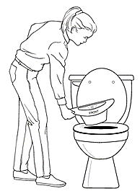
When measuring output, ask the person to use a urinal, bedpan, or plastic “hat” that fits inside the toilet bowl. These can be purchased at pharmacies and other stores.

If feces are mixed with urine, it may cause inaccurate measurements. Be sure to include this in the documentation.

If the person vomits, document the frequency, not necessarily the amount except in general terms such as small, medium, or large amounts. nationwidechildrens.org

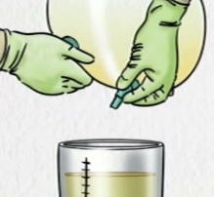
If the person wears incontinence briefs, those are weighed before and after use and the weights recorded. The weight of the person’s briefs when dry should be noted and subtracted from the weight when wet before recording.

Empty ostomy and catheter urine collection bags into a

measuring container to determine output amounts.

COLLECTION OF URINE SPECIMENS:

If a urine sample is needed for testing, you may be asked to obtain a “clean catch” urine specimen.

To keep the sample uncontaminated, it is important that the individual be clean before attempting to obtain the sample.
- Females should be wiped from front to back with a wet cloth or a specific wipe obtained from the medical provider’s office.

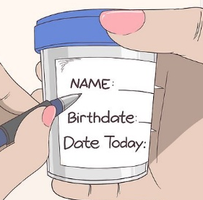
Do not touch the inside or top of the rim of the collection cup, the underside of the lid, or place the lid with the top side down on a surface.

Prior to collection, make sure the container is labeled with the client’s name, birthdate, and the date. Once the specimen is collected, place the container in the transportation bag or a sealable plastic bag. Set up the bag in advance so that the container can be placed into it without touching it. Then seal the bag closed.

Steps for urine collection:

Gather equipment and supplies.

Identify the person, provide privacy, and explain the procedure.

Wash hands and put on gloves.

Clean the genitals using disposable wipes if the person is unable to do that for themselves.

Have the person begin to urinate into the toilet. After the stream has begun, insert specimen cup into the stream and collect a modest amount of urine. Then remove the specimen cup from the stream as the person continues to empty the bladder.


If the person is unable to obtain the “midstream” specimen (per step “5” above), have the person urinate into a urine hat or urinal which has been thoroughly cleaned. Pour the sample into the specimen cup.

Record the date and time of the collection. Record when the specimen was delivered to the lab or medical provider’s office, etc. Note whether or not this was a “midstream” specimen.

URINARY CATHETER CARE:

External urinary catheters:
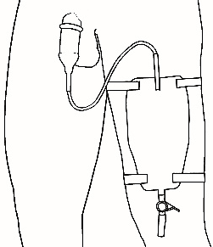
- These are sometimes called Texas catheters or condom catheters.
- They are rolled up onto the male penis like a condom.
- They have a tube that drains into a bag which should be emptied when it is half full.
- After the bag is emptied, rinse with cold water, close bag, and shake for 10 seconds. urotoday.com/library-resources/bladder-health
- Empty the water into the toilet and repeat.
- Then, using a mixture of 1 part vinegar to 3 parts water, fill the bag with this mixture until half full. Let sit for 30 minutes, and empty into the toilet.
- Rinse the bag with warm water and let air dry before using.
- Bags should be changed daily
- There are some external catheters made specifically for females, but they are not as easy to use.

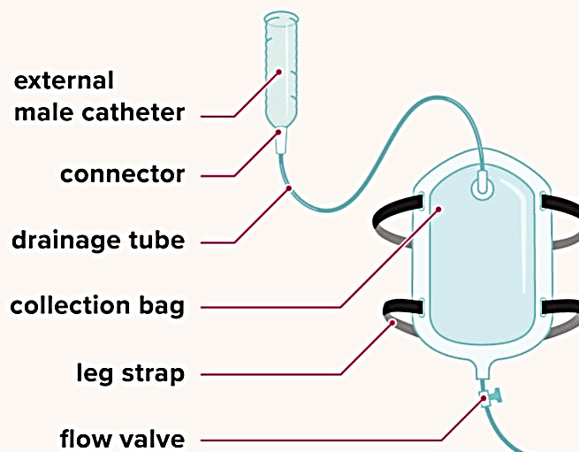

healthline.com

Internal (indwelling) urinary catheters:
- Must be inserted and removed by a licensed medical professional.
- These are inserted through the urethral opening or through the abdominal wall (suprapubic catheter).
- The tubing and the exit site must be cared for and cleaned to prevent infection.
- Care of the catheter exit site, cleaning catheter tubing, emptying catheter bags, and changing the bag or plugging the tubing can be done by DSP’s.
- Anyone with an indwelling catheter should shower, not bathe, as bathing increases the risk for infections. Someone with a suprapubic catheter may bathe with permission from the medical provider.
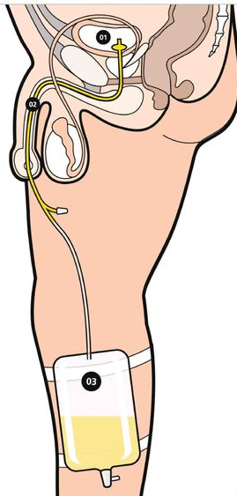
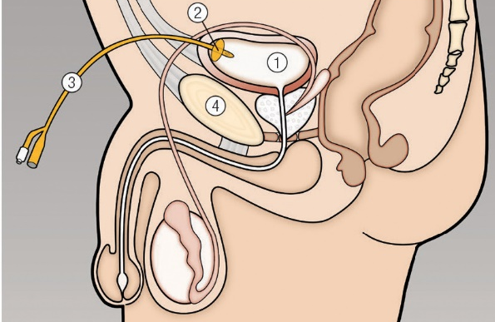

bladderandbowel.org
Suprapubic catheter (above):
- Bladder
- Retention balloon
- Catheter
- Pubic symphysis

Indwelling catheter (to the left):
- Bladder
- Catheter with retention balloon in bladder
- Leg bag

https://www.urology.co.nz/

Procedure for catheter care:

Gather equipment and supplies. Wash hands and put on gloves.

Identify person, provide privacy, and explain procedure. Have person lie back, exposing a small area where catheter enters body.

Be sure the catheter bag always remains lower than the bladder, so urine does not flow back into the bladder.

Wash the area surrounding where the catheter enters the body with mild soap (such as Dove®) and water.

If working with an uncircumcised male, retract the foreskin and cleanse area. Return foreskin to original position.


For a suprapubic catheter site, if there is a shield in place, gently wash under the shield with a cotton-tipped applicator. Some place a 4” by 4” sponge around the catheter and under the shield, cutting a slit in the sponge from one side to the center.

Wipe the tube, starting at the point where it enters the body and move downward toward the bag. Never wipe from the bag upward.

Check for any kinks or coils in the tubing and straighten if found.

Clean up any equipment and discard or return to storage area.

External catheter care tips:

Anchor the catheter securely to the person’s upper leg or abdomen using a non-tape binder (catheter tube holder) to prevent pulling.

Monitor the catheter system for kinking, obstruction, sediment, leaking, irritation or pulling.

Be sure tubing and bag are below level of the bladder when the person is up and about.

Always hang collecting bag so it does not touch the floor.

Report any redness, discharge, or irritation in the catheter area.

DO NOT:
- Pull on collecting bag or catheter.
- Disconnect the catheter tubing. If it accidentally comes apart, wipe the ends with alcohol and reconnect.
- Place the bag on the bed or raise above the level of the bladder. It must be lower than the bladder to promote drainage.

Steps for emptying the urine collection bag:

Gather equipment and supplies. Wash hands and put on gloves.

Identify person, provide privacy, and explain procedure.

Remove the urine bag outlet tube from its holding area and open it over an appropriate container for measuring. Drain contents of the bag, being careful not to splatter urine. Always keep bag below bladder level.

Re-clamp the outlet tube to the urine bag. Clean and dry the tip of the outlet tube before putting it back in its holder.

Record the amount of urine drained.

Report to medical provider or other healthcare professional of any unusual color or odor, and if the volume is unusual for the person.

Clean equipment and return to storage.

Tube holder
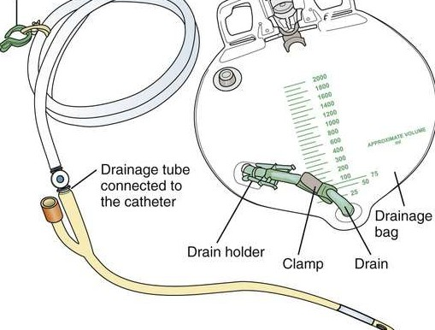

Drainage tubing→

Ohio DDD med manual

ORAL SUCTIONING:
There are times that clients have excess secretions in their mouths that they are not able to handle which can lead to choking and aspiration.
- Superficial oral suctioning can be performed by DSPs. This is suctioning inside the mouth only.
- DSPs cannot perform deep suctioning (down into the throat) or suction through a tracheostomy (tube in neck).

Procedure for oral suctioning:

Place suction machine on a sturdy surface and plug in.

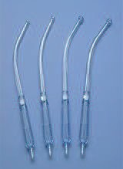
Wash hands and put on gloves.

Connect tubing to the outlet port on the lid of the collection container.

Attach the suction catheter device (called a Yankauer) to the other end of the tubing.

Turn on suction machine and check for suction pressure.

Follow manufacturer’s instructions for how to check and set for the correct amount of suction indicated for the individual. Ohio DDD med manual Excessive suction can be dangerous and painful.


Insert suction catheter into mouth, placing the tip of device where a toothbrush would go on the lower jaw. Circle the catheter around the bottom of the mouth for 15 seconds. Remove catheter, wait 15 seconds, repeat if necessary. Guardian Angels Training

If the person starts to cough or gag while suctioning, take the catheter out of the mouth until the person recovers. Then continue.

NEVER SUCTION FOR LONGER THAN 15 SECONDS.

After finishing, suction water through the suction catheter until the catheter and tubing are clear.

NEVER ALLOW THE FLUID IN THE COLLECTION CONTAINER TO RISE ABOVE THE FILL LIMIT LINE.

Turn machine off, empty collection container and clean thoroughly before putting equipment away.

Document and note any concerns or problems encountered.

ASSISTING WITH COMPRESSION HOSE (stockings):

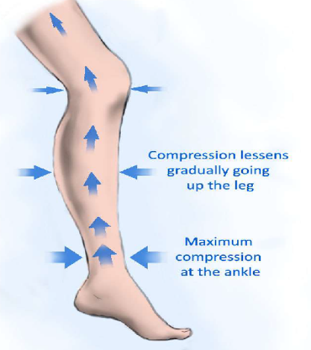
Compression hose are a special kind of elastic leg wear designed to squeeze the legs to help move blood upward. They are tightest at the ankles, becoming less tight farther up the leg.

Increasing blood flow back up the leg (increasing circulation) can help:
- prevent blood clots.
- prevent phlebitis (inflammation of the superficial veins).
- decrease edema (swelling of the leg).

Compression hose (TED® hose):
- are best applied first thing in the morning before fluid has a chance to accumulate in the tissues.
- should be washed by hand daily and hung to dry.
- should be completely dry before putting on.

Application of compression hose:

Make sure the person’s feet and legs are clean and dry.

Do not put the hose on wet skin.

Make sure there are no open sores or skin infections.

Do not apply hose over any wounds.

Place your hand in top of clean, dry hose and pull hose up your arm until your hand is in the foot of the hose.

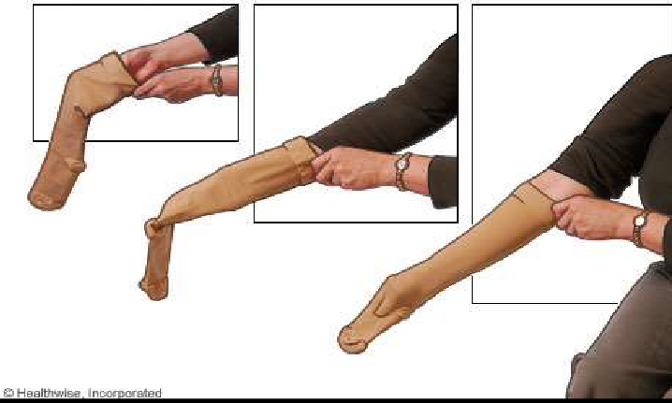
Roll hose inside-out, down over your arm to your hand, while keeping a grip on the inside of the toe.
Ohio DDD med manual

Grasp edges of hose and place person’s foot into the toe of the hose. Work the foot of the hose over the person’s foot.

Be sure the toe and heel are in the proper place.

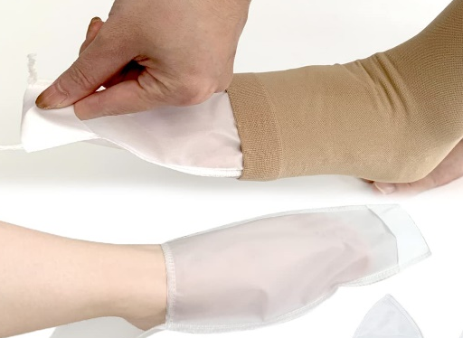
Smooth material over foot with no ridges or bunching.

If the hose has an open toe, a plastic bag can be placed over the foot to make it easier to slide the hose on and then the bag is pulled out through the open toe.

Amazon.com

Grasp the edge of the hose and pull it up over the ankle and calf.

For knee length hose, ensure that the top of the hose is 1 to 2 inches below the crease at the back of the knee. NEVER roll the top of the hose down.

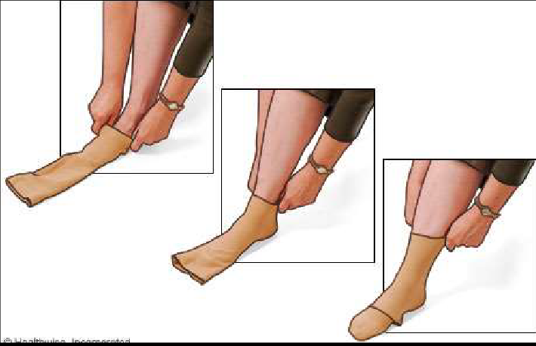
For thigh length hose, pull the hose over the thigh until it is 1 to 3 inches below the buttocks. NEVER roll the top of the hose down.

Ohio DDD med manual

Ensure the hose fits smoothly over the skin and has no wrinkles or folds. If there are wrinkles, roll hose back to below the wrinkle and re-work back up the leg.

There are special compression sock aids that can be purchased. These make the act of putting on the stockings easier for people to accomplish themselves.

Appendix 3. GENERAL INFORMATION

CONTROLLED SUBSTANCES
The Federal Controlled Substances Act was put into place to identify and control the access to substances that have a high potential for abuse. Those substances are placed into five categories referred to as Schedule I to V. Schedule III through V drugs are the regular drugs prescribed with no special needs for prescribing.

Schedule I drugs are used for research, have a high potential for abuse, and do not have legitimate medical uses. This includes:

THC (marijuana)

CBD (cannabidiol) with a concentration over 0.3% THC.

Schedule II drugs


High chance for abuse but do have legitimate medical uses.

Include many of the opioid pain relievers (morphing, hydrocodone, oxycodone, etc.
OPIOIDS

Include methylphenidate (Ritalin®) and other

amphetamines.

A written prescription on special paper is required; no refills allowed.

When present in a group home, Schedule II drugs:
- Must be stored in a locked cabinet or other secure area.
- Must have documentation tracking each dose.
- Must have “med counts” at shift exchange in group homes (or other times in Supported Living) with documentation on a narcotic or controlled substances count sheet to account for all medications.

STORAGE OF MEDICATIONS

Medications can break down if not stored properly. Three important factors must be met when storing medications: environmental conditions, security/access, and convenience.

Storage and preparation areas:

Must provide adequate space and lighting.

Must have accessible hot and cold running water.

Must have secure cupboards or containers with countertop space for preparation of medications.

Refrigerator storage:

If possible, a separate refrigerator for medications should be used.

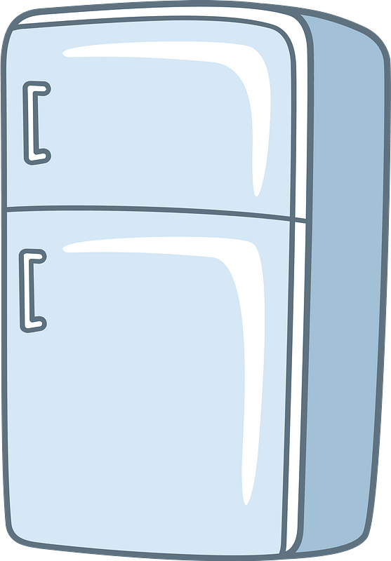
If a separate refrigerator is not possible, there must be a dedicated area in the refrigerator used only for medications.

Medications must be placed in a container to protect from contamination.

Medications stored in any refrigerator must be secure.


SPECIAL CIRCUMSTANCES

Sun Sensitivity:

Medications may cause increased sensitivity to the sun causing sunburns.

Medications that do this include:
- Some antibiotics (tetracycline, ciprofloxacin, etc.)
- Anti-psychotics (Risperdal®)
- Diuretics
- Naproxen
- Trazodone
- Oral contraceptives

When taking those medications:
- Limit exposure to the sun.
- Wear protective clothing and apply sunscreen when outside.

Changes in color of urine:

Some medications change the color of the urine, for example:
- Black urine: iron, laxatives, nitrofurantoin, metronidazole, sorbitol.
- Red urine: ibuprofen, warfarin.
- Orange urine: sulfasalazine.
- Brown urine: nitrofurantoin, metronidazole.
- Blue or green urine: amitriptyline, methocarbamol, metoclopramide.

Color changes are generally not harmful and resolve after stopping the medication.


off-site and home medications
When a client goes for a visit home, on an outing, or is at a different site during the day, medications still need to be taken.

For trips or home visits, medications may need to

be repackaged by the pharmacy so that only the amount needed is sent with the person.

Send the medication information sheet and a copy of the MAR along with written instructions about each medication.

Review the medications with responsible party prior to leaving.

While the client is gone, mark the MAR with an “H” for home visit or another appropriate symbol for those doses not given at the group home or work site.

When the client returns, ask about the medications, including if any doses were missed, or if any adverse reaction occurred.

For Day Services or Work, a supply of medications will be needed at that site along with a MAR that can be used when meds are taken.

Paper MARs must be maintained at both sites and each needs to indicate when and where the drugs are given.
- For example, the MAR at the group home could have a simple line drawn through the times that the drugs are given at the workplace.
- Define whatever is used so that it is known when and where the medications are given.

Electronic MARs may be used and should be able to be accessed at both sites.

GUIDELINES FOR WRITING PROTOCOLS

PRN PROTOCOLS - EVERY PRN MEDICATION MUST HAVE A WRITTEN PROTOCOL.


PRN medication protocols (whether for OTC or prescribed medications) must contain:


Name of the person receiving the medication.

Name of the PRN medication.

The exact dose that is to be given:
PRN

There cannot be ranges of doses such as “give 1 to 2 tablets” but the protocol must specify either 1 tablet or 2 tablets for a given use.


How often the medication can be given, specifically:

The maximum dose that can be given in 24 hours (for example: “not to exceed 6 tablets per 24 hours”). “Not to exceed” is often written as NTE.

The minimum amount of time between doses (for example: may take 2 capsules every 4 hours, or “may repeat” in 6 hours). May repeat is often written as “MR”.

There cannot be a range in time, i.e., “give every 4 to 6 hours”. The order and protocol must have exact times such as “may give every 4 hours if needed”.

The conditions or symptoms for which the medication can be given:


For a runny nose and itchy eyes, an antihistamine may be given for allergies, or

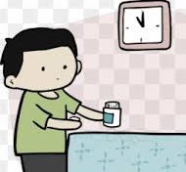
For temperature of 100 degrees or more, give acetaminophen 325 mg, 2 tablets, may repeat in 4 hours. NTE 6 tablets per 24 hours.”

The route by which the medication is given (oral, topical, rectal, etc.).

The length of time or time frame for giving a medication before staff must respond in a different way such as notifying the medical provider or a nurse, etc. Examples:

“Notify MD if medication is taken for more than 3 days in a row.”

“If symptoms do not resolve in 5 days, notify the physician.”

“If symptoms persist more than 2 days, or worsen, notify MD.”


Documentation must occur on the Medication Administration Record (MAR) and include:

Name, date, time, and dose of the medication and staff initials.

Reason the medication was given (for example: headache or elevated temperature).

The response by the individual to the medication (for example: headache discomfort resolved in 30 minutes).

Incident reports must be written per policy.

PRN psychotropic medication protocols:

PRN psychotropic and other medications used for behavior, or a psychiatric reason may never be used for the convenience of staff but must have clear and objective guidelines for use.
PRN

PRN psychiatric medications are never to be used in place of behavioral support strategies.

PRN psychiatric medications are never to be used as punishment.

PRN psychiatric medications are never to be used as a chemical restraint.


Protocols must be written according to “a through h” listed on the preceding page for other PRN medications, but also must include a rationale or reason for use which would include:


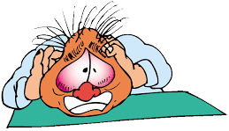
Circumstances prior to use (triggers for the behavior). Behavior prior to use (physical signs, indicators of pain, etc.).Target behaviors (defined in observable and measurable terms).


Steps taken or supports given to avoid use of PRN medications such as taking the person for a walk to calm down.


Protocols must include a system for reporting or sending notifications when PRN medications are used for behavioral issues and for recording data (incident reports) and how often data is shared with the team and medical or psychiatric provider.

SEIZURE PROTOCOLS:

Description:

Describe the type of seizure such as generalized motor, focal, etc.

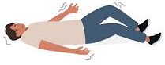
How do the seizures present (what do they look like): shaking, staring, tonic-clonic, etc.?

Are all the seizures the same?

Are there any warning signs (aura)?

How long do they generally last?

What triggers are known: lack of sleep, bright lights, noise, etc.?

When do they generally occur: at night, when person is ill, etc.?

How does the person behave after the seizure?

Monitoring:

Describe how the client is to be monitored including:

How often is the person checked during the night and the day?

How will staff monitor the client while bathing/showering?

How will staff monitor the client when in the restroom?

Staff response:


Immediately time seizure.

Make sure the person is safe from harm.

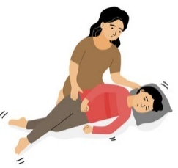
If VNS unit is an option, include when and how to use it and where the magnet can be found.

If the person has prn medications, describe in detail when and how these are to be used including where they are located.


Describe when staff should call for assistance from a manager, nurse, medical provider, etc.

Describe when staff should call 911.

Describe how staff will document the seizure including the people who should be notified.

Describe how staff will monitor the client immediately after a seizure.

EATING PROTOCOLS:


NEED – Eating protocols are needed when:

There are identified choking risks.

There is a history of choking or aspiration.

There is a special diet.

There are special needs for eating such as certain utensils, cues, or prompts, etc.

RISKS:

List the risks for choking and aspiration that are exhibited by the client.

List the results of a swallowing evaluation if one was done.

List the ways risks are to be reduced/managed:


Special diet.

Special utensils or dinnerware.


Appropriate positioning during and after eating; include how long the person should remain seated after finishing.

Staff interaction: sitting next to the person, cueing to slow down or chew more, encouraging the person to remain seated, etc.


DIET:

Food texture: pureed, ground, chopped, etc.


If food is to be served chopped, exactly how big are the bites? Give measurements or examples, such as M&M sized, ½ inch, etc.

List which foods should be avoided.

List which foods the client likes or does not like.

Describe the consistency of liquids: thick or thin?

If thickened, describe level of thickness and how staff are to prepare liquids.
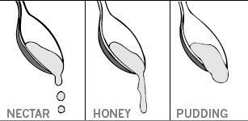

/www.hrh.ca/patient-education

DIABETES MONITORING:

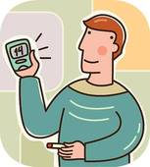
When to check levels:

List when levels are checked: fasting, before meals, etc.

Include if and when they can be checked. Can they be checked on a prn basis for symptoms/signs of hypoglycemia?

What to do if level is high (hyperglycemia):

List levels of glucose and what to do for those levels such as:

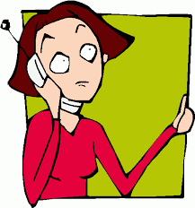
Call medical provider if level is above ______.

Call 911 if level is above ______.

Insulin protocol – insulin can be given prn only if there is someone who can administer the insulin, or if the client can self-determine the dose and self- administer the insulin. (DSPs cannot determine insulin doses, draw up insulin or dial in a dose on an insulin pen, nor administer insulin.)

What to do if level is too low (hypoglycemia):

List levels of glucose and what to do for those levels such as:

Call 911 if level is below _____.

Call medical provider is level is below_____.

When to give glucose supplements such as fruit juice.

List exactly what glucose supplement is to be used and how much staff are to give.

When the glucose level should be rechecked if abnormal:


Describe what should be done if level is still too low or too high.

When should 911 be called.

Appendix 4. medication forms & administration

ORAL MEDICATIONS


Tablets and capsules:

The most common route for taking medication is through the mouth.

When in the stomach, medications require adequate fluid to dissolve and be absorbed.
- A full glass of water, 8 fluid ounces, is optimum.
- Taking enough fluids also decreases stomach upset.

Tablets and capsules come in different forms depending on how fast they are absorbed into the blood stream. These forms include:
- Immediate release (IR)
- Delayed release (DR)
- Sustained release (SR)
- Extended release (ER, XR, CD, XT, LA, HS, PM)
- Controlled release (CR)

The different forms of medications are not interchangeable. For example, bupropion (Wellbutrin®) comes in different forms:
- Wellbutrin®, an immediate release form, taken three times a day.
- Wellbutrin SR®, a sustained release form, taken twice daily.
- Wellbutrin XL®, an extended-release form, taken once daily.

Rectal medications:

Anti-emetics: used to relieve nausea and vomiting.

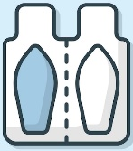
Phenergan®, Compazine®
- Can cause sedation, dizziness, blurred vision, dry mouth, and sun sensitivity.

Analgesics (for relieving pain) and antipyretics (reduce fevers). Freepik.com

Aspirin, Motrin®, Tylenol®
- Can cause tinnitus (ringing in the ears) and GI upset.

Laxatives: used to relieve constipation (enemas or suppositories).

Glycerin, Dulcolax®, Fleets®
- Can cause nausea and vomiting as well as abdominal cramping.

Hemorrhoid treatments: relieve itching and burning from hemorrhoids.

Preparation H®, Proctofoam®
- Can cause redness, burning, allergic reactions, and rectal bleeding.

Vaginal medications:

Anti-fungal: used to treat yeast infections.

Gyne-Lotrimin®, Monistat®

Anti-infective: used to treat infections of the vaginal walls.

Metronidazole, clindamycin

Lubricants: used to lubricate dry mucous membranes.

K-Y Jelly®, estrogen cream

All can cause burning, itching, or stinging.

More information on Oxygen therapy

Steps for Giving Oxygen Therapy (especially if given intermittently):

Check order on MAR for oxygen therapy guidelines

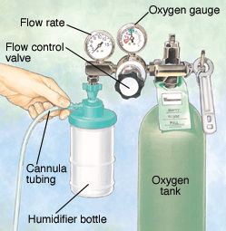
Gather oxygen supply and equipment. Clean equipment if dirty.

If using a tank, confirm the tank supply level is adequate.

If using a concentrator, make sure it is plugged in and away from walls.

Identify the person to receive oxygen and explain the process.

Connect the nasal cannula or mask to the oxygen source.

Adjust flow rate according to MAR or order. Check that oxygen is flowing. mountnittany.org.

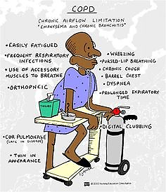
Place cannula in the person’s nostrils; or place mask on the person’s face. Adjust for comfort.
- If using a cannula, instruct the person to breathe through nose with mouth closed.
- If using a face mask, instruct person to breathe through nose or mouth.

Document when oxygen administration was initiated. If the oxygen is being used “as needed”, record reason for the need and the response.

For prolonged sessions, check the flow rate, oxygen supply, and flow through the cannula or mask every two hours.

Perform pulse oximeter readings if directed by the order and record.

Oxygen cylinder:

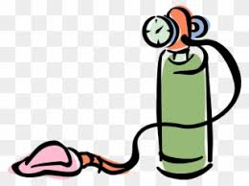
Store oxygen cylinders upright in a well-ventilated area at least 10 feet away from a heat source (heater, gas stove, etc.) any open flame, electrical devices, or direct sunlight.
- Do not cover with cloth or plastic.
- Do not store in closets, behind curtains, or other confined spaces.
- Secure cylinder on a stand with a strap to hold in place.

Handle the cylinder gently to avoid damaging it.

If transporting, place carefully on back seat. Secure to keep from rolling. Do not transport in the trunk or bed of truck.

Be sure to use the correct pressure gauge and regulator.

When almost empty, close the valve and mark the cylinder is empty. Don’t store empty cylinders together with the other cylinders.

Oxygen concentrator:
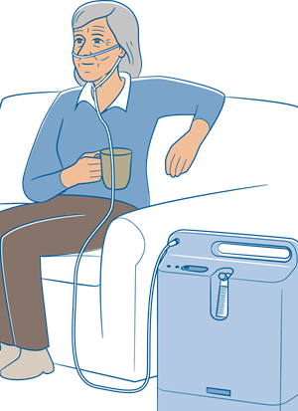
These filter nitrogen out of the air, providing almost pure oxygen.

Be sure the concentrator is plugged into an

electrical outlet. Never use an extension

cord or power strip.

Keep concentrator away from curtains or drapes, place in a well-ventilated area.

Do not store or keep in a closet or other confined space.

Be sure to have it inspected and service per supplier instructions.

Steps for cleaning oxygen equipment:

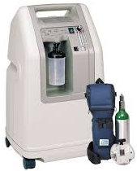
Oxygen concentrator:
- Clean at least weekly.
- The outside can be wiped with a damp cloth and mild dish detergent.
- Never spray cleaner directly on machine.

Cannula/mask:
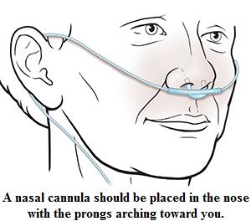
- Clean daily and if visibly soiled, or after intermittent use.
- Use mild dish detergent, and rinse well.
- Towel or air dry.
- Replace every two weeks.

saintlukeskc.org

Tubing: replace monthly.

Water trap:
- Empty as needed.
- Remove at least twice a week, clean with mild dish detergent, and rinse.

Humidifier bottle:
- Use only distilled or sterile water
- Empty daily and replace with fresh distilled or sterile water
- Clean and disinfect at least twice a week. First wash with mild dish detergent and rinse well; then soak in 1-part water and 1-part distilled white vinegar. Rinse thoroughly.

Appendix 5. ADMINISTRATION OF MEDICATIONS

WHAT MUST You KNOW ABOUT A MEDICATION BEFORE ADMINISTERING IT?

What is the purpose of this medication for this person?


How much medication and how often should the medication be taken?

Are there any special instructions?

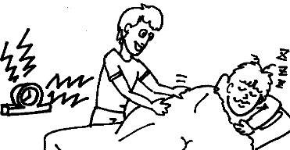
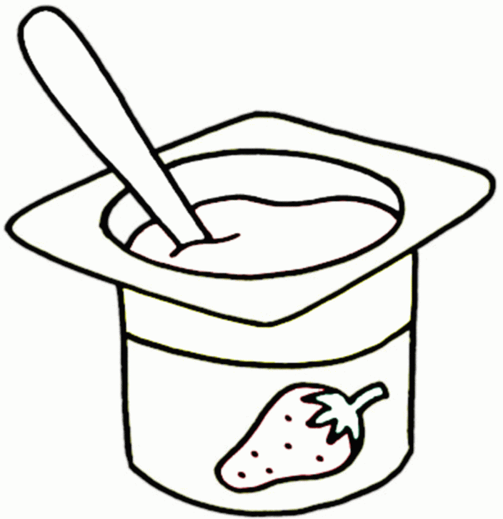
Should it be given with food or on an empty stomach?

What should be done if a dose is missed?

Can the medication be given early or late and if so, how early or late?
- NOTE: medications are to be given within a two-hour window of the time ordered. This means a medication that is ordered for 7 am can be given at any time between 6 and 8 am.
- If someone generally sleeps in on weekends, obtain an order to give the medication later than usual so the person doesn’t have to be awakened.
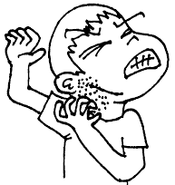
- There must be a specific order from the prescriber to give a medication early or late which includes just how early or late the medication can be given.

What should be done if an incorrect dose is given?

What side effects may occur, and can they be prevented?
- What should you do if you see a side effect?
- How should you report it?

Do blood levels need to be checked? When, and how often?


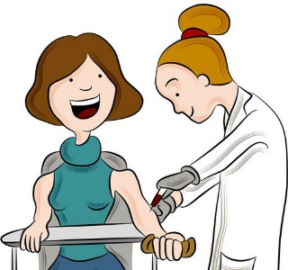

Are there any foods, other medications, supplements, or anything else that should not be consumed with the medication?

standard precautions
Most people use the term “Universal Precautions” regarding the control of the spread of infections, but “Standard Precautions” is the correct term to use.

Universal Precautions:
- Were first introduced by the CDC in 1987 to prevent the spread or transmission of blood borne pathogens to health care providers.

Standard Precautions:
- Were established in 1996.
- Apply to blood and all body fluids, secretions, and excretions, except sweat, regardless of visible blood.
- Apply to non-intact skin and mucous membranes.
- Confirmed that body fluids are potential carriers of infectious diseases and should always be treated as though they are contaminated.

In addition to Standard Precautions, there are also:


Airborne Precautions:
- Which protect from the very small particles in respiratory secretions which remain suspended in air for extended periods.
- Include tuberculosis, chicken pox, measles, etc.

Contact Precautions:

- Are used for infections, diseases, or germs that spread by touching therefore gloves must be worn.
- Gowns are required if there is a chance that clothing will come in contact with the person or if the person has diarrhea
- Apply to MRSA, scabies, impetigo, herpes simplex, herpes zoster.
- The person should remain in his/her room as much as possible.

Droplet Precautions:
- Are for large droplets that are produced by coughing, sneezing, talking, and exhaling.
- Droplets remain suspended in the air for limited periods.

- Transmission is associated with exposure within 3 to 6 feet of source.
- Masks must be worn when within 6 feet of a patient.
- Patients must wear masks when out of their rooms.
- Apply to influenza, whooping cough, Rubella, mumps, etc.


PHARMACY LABELS
Medications dispensed by the pharmacy must remain in the original labeled container. The information listed must be included even when using pill caddies. Under Administrative Rules of Montana, Board of Pharmacy:
24.174.832 LABELING FOR PRESCRIPTIONS
(1) On prescription drugs, the label shall contain the name, address, and phone number of the dispenser, name of prescriber, name of patient, name and strength of the drug, directions for use and date of filling.
(2) The prescription label must be securely attached to the outside of the container in which the prescription is dispensed.

preparation of medications

Getting medication from the original container to the dispensing cup:

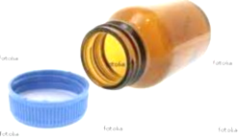

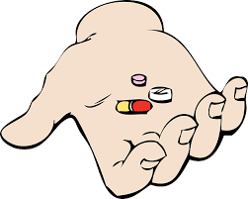
When administering medications from a bottle or vial, be careful not to touch the medication with your fingers or place in your bare hand. Be sure to put on gloves.

The medication is poured from the container into the lid of the container, then from the lid, into the dispensing cup. Ohio med certification guide

Getting medication from a blister (bubble) pack to dispensing cup:

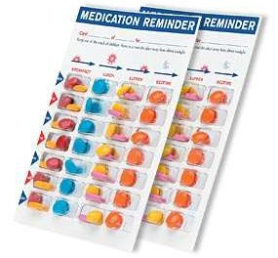
The packaging for medications placed into compartments for a given period of time such as a week or month is called a blister pack or bubble pack.

Medications are in numbered windows.

For each medication, place the dispensing cup under the correct window and push the pill into the dispensing cup.


Make sure these packages are fully labeled and that you know you are administering the correct medication. Ohio med certification guide

Compare the meds to the MAR before giving.

Getting medications from a multi-dose pack to the dispensing cup:

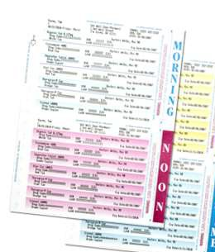
Multi-dose packs have all the medications for a specific time together. The prescription information and description of each medication must be included on the package.

Identify each pill/capsule and compare it to the label and the MAR before placing it into the dispensing cup.

Ohio med certification guide

Pill “caddies” or pill “minders”:

Any client who can fill and use a pill caddy has the right to do so. The client must be able to independently self-administer medications or self-administer with minimal assistance.

Only licensed healthcare professionals can fill pill caddies for individuals who cannot fill them without assistance.

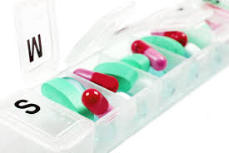
Unlicensed staff may administer medications from a pre-filled pill caddy if the pill caddy is filled by a pharmacist or licensed healthcare professional and labeled with enough information to ensure staff can determine that they are giving the correct medication.

administration of medications – procedures:

E1. SUBLINGUAL OR BUCCAL MEDICATIONS

Medications are sometimes given via the sublingual or buccal route. This can be because the medication needs to get into the system faster, the person has trouble swallowing medication, the medication doesn’t absorb well in the stomach, or the effects of the drug would be decreased by digestion. The cheek and area under the tongue have many tiny blood vessels (capillaries) and drugs can be absorbed directly into the bloodstream without going through the digestive system.

Procedure:

Gather the medication and MAR and compare information.

Wash hands and put on gloves.

Assist the person into an upright or sitting position.

If the person receives sublingual or buccal medication on a regular basis, change to different sites under the tongue or in the cheek area to prevent development of irritation. If any sores or irritation are present, notify the medical provider.

For sublingual medication:

Ask the person to open mouth and raise tongue.

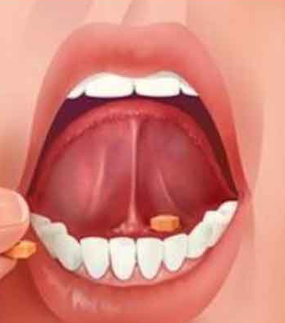
Place tablet or assist the person to place the tablet under the tongue.

If assisting person to lift his tongue, use gauze

pads to help hold onto and lift the tongue.
- If giving a sublingual spray, hold the spray about an inch away from the site and instruct the person to hold his breath before spraying.

Refrain from eating or drinking for 30 minutes. pharmapproach.com/buccal-

and-sublingual- routes

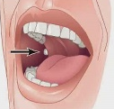
For buccal medication:

Ask the person to open mouth and expose cheek/gum area.

If assisting the person, gently apply downward pressure on the lower lip.

Place the tablet between the inner aspect of the cheek and gum or teeth.

If administering a liquid medication, insert the syringe or dropper into the buccal cavity and slowly administer the medication.

Encourage person to keep mouth closed until medication has dissolved. Refrain from eating or drinking for 30 minutes.

Stay with the person until the medication is dissolved.

Remove and dispose of gloves and wash hands before documenting.

Document in the MAR and include any complaints, concerns, or actions taken.

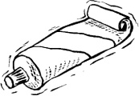
E2. Topical medications:

skin creams or ointments

Gather the medication and MAR. Check information.

Explain to the person the name and purpose of the medication.

Provide privacy as needed.

Assist the person into a position that allows for safe application of the medication.

Wash hands and put on gloves.

Look at the area where the medication is to be applied.

If there are orders to cleanse the area or if the area is soiled, use soap and water to clean, then dry thoroughly.

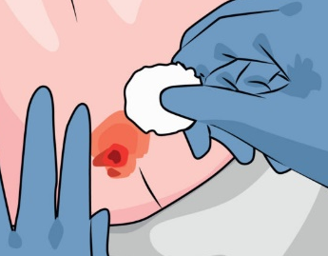
Apply the medication according to the directions.

Leave the person in a comfortable position and supervise as indicated.

Remove gloves and other materials as applicable, wash hands. Document appropriately.

axiobio.com/wound-care

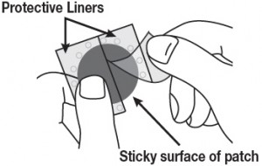
E3. transdermal medication

Gather medication and the MAR.

Check the information on MAR; compare to drug container and prescription label.

Explain the purpose of the medication, provide privacy as needed.

Assist the person into a position that allows for safe application. rxdruglabels.com

Wash hands and put on gloves.

Remove old patch. Gently wash and dry the area.

Observe for skin irritation, record, and report if present.

Select a new site, clean and dry the area. Never apply over irritated areas, scars, calluses, folds, or tattoos unless approved by medical provider.

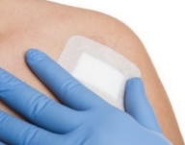
Apply patch; write date it was applied onto the patch as a double check.

Dispose of the old patch. Remove gloves and wash hands. Document that patch was placed.

E4. eye medication
Eye Drops:

Gather medication and check it against the MAR .

Wash hands and put on gloves.

Eye drops may come in a bottle with a dropper built into the cap, or a bottle with a dropper portion built in as a part of the bottle. If there is a dropper, keep the bottle upright to prevent the liquid from flowing into the dropper bulb. If the dropper is part of the bottle, it will be necessary to invert the bottle to get the liquid to the dropper mechanism.

Have the person sit down with the head tilted back slightly, looking up at the ceiling. Explain what you are going to do.

Using one hand, gently pull down on the lower eyelid to form a pouch.

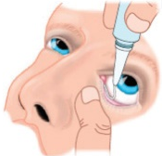
Using the other hand, place your palm on the person’s forehead to use as a support.

Hold the dropper or dropper bottle between the thumb and index finger.

Hold the end of the dropper about an inch above the eye, being careful not to touch anything with the dropper. journals.rcni.com Never let the dropper tip touch the eye.

Gently squeeze the dropper to instill the prescribed number of drops into the pouch of the lower lid. Do not drop onto the eye itself.

Ask the person to close the eye for a minute to allow the medication to be distributed around the eye and to be absorbed.

Repeat the procedure in the other eye if needed. Replace the cap tightly.

Wash hands, chart on the MAR that the medication was given.

Note if there were any problems such as an unusual reaction or symptom following administration.
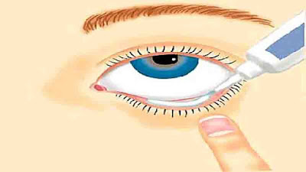
Eye Ointment or Cream:

Gather the medication, cotton balls, and the MAR.

Check information on the MAR; compare to label.

Wash hands and put on gloves.

Have the person sit or lie down and explain the procedure. eyeproblem.org

Cleanse the eye gently with a cotton ball. Wipe from the inner corner outward once. Use a clean cotton ball for each eye.

Remove the cover from the ointment tube.

Position with head tilted slightly back, looking upward, pull lower lid down slightly.

Approaching the eye from below, gently squeeze the tube and move it along the inside lower lid, instilling about a 1-centimeter (1/3 inch) thread. Break off the ribbon from the tube by releasing pressure and removing the tube – do not use your fingers. Do not place ointment onto the eye itself. Never let the tube tip touch the eye.

Ask the person to close the eye for a minute to allow the medication to be distributed around the eye and to be absorbed.

Repeat the procedure for the other eye if needed. Replace cap tightly.

Remove gloves, wash hands; chart that medication was given.

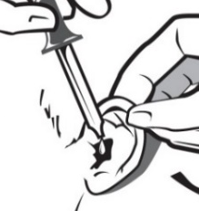
E5. ear (otic) medications
- Note: before instilling ear drops, straighten the person’s ear canal by grasping the center of the outer ear and gently pulling back and up.

Gather medication, cotton balls, and the MAR and check information on the MAR.

Have the person sit in a chair, tilting the head sideways until the ear is as horizontal as possible.

Put on gloves. Cleanse the entry to the ear canal with a cotton ball.

Administer ear drops by pulling the mid-outer ear gently backward and upward to straighten the ear canal, then instill the ordered number of drops into the ear canal.

To prevent contamination, do not touch any part of the dropper to the ear.

Encourage the person to stay with head tilted to the side for 2-3 minutes.

Remove and dispose of gloves. Wash hands. Document on MAR.

E6. nose (nasal) medications

Gather medication and MAR, check information, and compare to label.

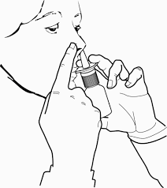
Have the person sit in a chair, position according to manufacturer’s instructions, and explain the procedure.

Have person blow nose before starting.

Wash hands and put on gloves.

Instill the medication per manufacturer’s instructions.

Instruct the person not to blow his/her nose for at least 15 minutes after instilling the medication.

Remove and dispose of gloves and wash hands.

Document that the medication was administered and document any complaints or concerns.

E7. rectal medications

RECTAL SUPPOSITORIES:
Many medications can be given via a rectal suppository, which is especially useful if someone is having difficulty taking oral medications.
- Store suppositories in a cool place and avoid melting.

Gather medication and MAR, check information, and compare to label.

Wash hands. Provide privacy for the person.

If the suppository is soft, hold it under cool water or place it in the refrigerator for a few minutes to harder before removing wrapper.

Prepare client by having him/her lie on the side with lower leg straightened

and upper leg bent forward toward the stomach.

Put on gloves and remove the wrapper.

Lubricate the suppository tip with a water-soluble lubricant such as K-Y Jelly, not petroleum jelly(Vaseline) as that may keep the suppository from melting once inserted.

Lift the upper buttock to expose the rectal area.

Insert the suppository, pointed end first, with your finger until it passes the muscular sphincter of the rectum, about 1 inch. (If not inserted past this sphincter, the suppository may pop out.)

Hold the buttocks together for a few seconds.

Have the person remain lying down for about 5 minutes to avoid having the suppository come out.

Discard used materials and wash hands thoroughly.

Document that the medication was administered and any concerns.

Clipart for rectal suppository instructions are from kbiesecker@ashp.org

ENEMAS:
An enema is injection of fluid through the anus and into the rectum to clean stool out of the bowel and stimulate the bowel to empty.

Uses:
- To treat constipation.
- To clean out the colon prior to sigmoidoscopy or colonoscopy.
- To clean out the colon prior to certain surgeries.
- To deliver medications to the colon as treatment for inflammatory bowel disease.
- To deliver barium to coat the lining of the colon during x-rays.

Administration:

Enemas require an order from a medical provider.

Medication certified staff may give enemas after appropriate training.

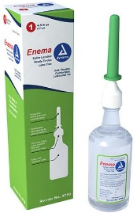
Training may be done by others including experienced DSPs, group home managers, etc.

Documentation of training and proficiency must be done.

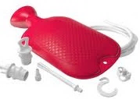

Staff may only give enemas from a prepackaged kit containing a prefilled dispensing bottle with a soft tip.

Staff may not mix enema solutions.

Staff may not use an enema kit that contains tubing and a bag that must be filled.

mfimedical.com

Risks:

Enemas do have associated risks when performed at home or if they are used too frequently. Complications include:

Disruption of the natural bowel flora.

Pain if the liquid used is too hot or too cold.
- Cold solutions may cause contractions that force the solution out of the rectum too fast.
- Hot solutions can be irritating to the lining of the rectum.

Damage to or perforation of the bowel wall which can cause sepsis.

An imbalance of electrolytes in the body.

If used too often, they can weaken the muscles of the intestine making the person dependent on enemas to have a bowel movement.

Instructions for giving an enema:

Gather supplies: the enema kit, gloves, lubricant, and towels.

Warm the enema solution to body temperature by placing in a container of warm water.

Lay towels over the place that you will be administering the enema and have other towels within reach.

Wash hands and put on gloves.

Have the person lie on their left side with the right knee bent - place a rolled up towel under the right knee for support. Alternatively, the person may lie with both knees bent if that is comfortable for them.

Remove the cap from the tip of the enema nozzle - apply lubricant such as K-Y jelly to the person’s anus to make insertion easier. Apply lubricant to the enema nozzle if not pre-lubricated.

Gently insert the tip of the enema nozzle into the rectum slowly with a slight side to side motion, the tip pointing towards the navel. The enema tip is generally about 3 inches long. Do not force the tip into the anus as this may cause injury. Insertion may be uncomfortable but should not be painful. It there is pain, stop and call the healthcare provider.

After insertion, slowly squeeze enema container to push liquid into rectum. Squeeze from bottom to top. The container will not completely empty.

Monitor for cramping. If signs of cramping occur (such as muscle tension in the abdomen), temporarily stop the flow of the fluid.

After the bottle is nearly empty, slowly withdraw the nozzle.

Have the person remain in that position and try to retain the enema for the recommended time listed on the box

Call a healthcare provider:
- If there is no liquid exiting the rectum within 30 minutes.
- If there is significant bleeding - more than a few drops of blood.
- If there is ongoing cramping or a fever.

Clipart under Instructions for giving an enema from:semanticscholar.org/paper/How-to-administer-an-enema

E8. vaginal medications

VAGINAL SUPPOSITORIES, TABLETS, OR CREAM:
Suppositories and creams are used to deliver medications to the vagina.

Gather medication, MAR, and a protective pad or towel.

Identify person and explain the procedure; provide privacy. Wash hands.

If the suppository is soft, hold it under cool water or place it in the refrigerator for a few minutes to harden before removing wrapper. Storing in a cool place helps avoid softening or melting.

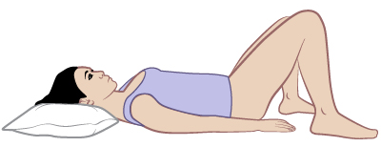
Have the person lie on her back with knees bent. Provide privacy with a thin blanket. Place towel or protective pad under buttocks.

Put on gloves. Gently wash the outer parts of

the area surrounding the vagina with mild soap and water, but do not wash inside the vagina. Rinse and pat dry.

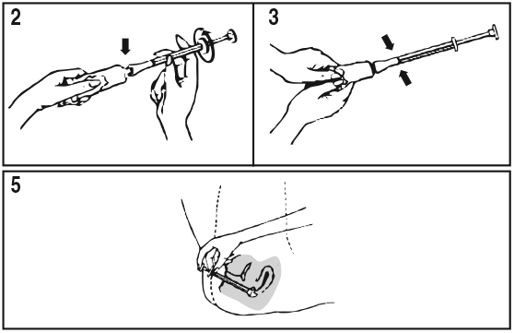
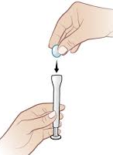
Unwrap the applicator from its packaging

and determine if it is already pre-filled with a tablet or cream. If it isn’t pre-filled, unwrap the suppository or tablet and place on the end of the applicator. If using a cream, fill the applicator with cream by connecting the tube to the applicator and squeezing the

tube until the correct dose is in the applicator. The applicator will have marks that indicate how much cream is in the applicator.

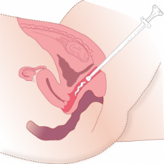
Separate the lips (labia) of the vulva which will expose the vaginal opening. Gently insert applicator into the vagina. Angle applicator slightly downward toward the tail bone. It will usually go in about 2 inches. Do not force. Push the plunger so the suppository or tablet is delivered, or the cream is pushed out of the applicator.

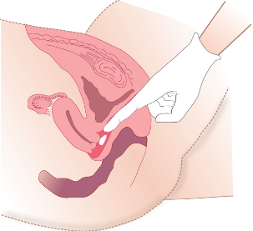
If a suppository or tablet was inserted, have the person sit or lie still for about 10 minutes to allow it to dissolve. Some of the medicine may leak back out. A pad may be used to line the underwear but do not use a tampon as it may absorb some of the medication.

Discard used materials. Wash hands and the applicator if it is to be reused.

Document administration, note any concerns.

E9. inhaled medications
Metered Dose Inhaler:

Gather medication and MAR; check information and compare to label. Wash hands and put on gloves.

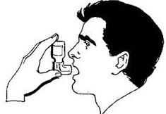
Identify the person and assist to a comfortable sitting position; explain the procedure.

If the canister is new and has never been used, you will need to prime it first. If the inhaler hasn’t been used in several days, read manufacturer’s instructions as to how many days can go by before it needs to be primed. If used daily, there is no need to prime.

To prime:

Remove cap and invert canister. Shake well.

With mouthpiece pointing away from everyone and into the air, press once on the canister base.

Prime canister per manufacturer’s instructions (usually twice).

If using a spacer:

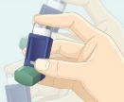
Remove the cap, invert the canister, and shake well.

Insert the canister into end of mouthpiece.

Have the person exhale.

Bring spacer to the person’s mouth and have them close lips around it.

Press the top of the canister once.

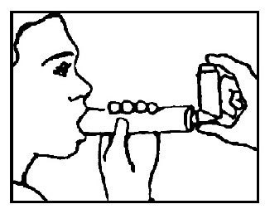
Have the person breathe in very slowly.

Remove mouthpiece and have person hold their breath for as long as possible – 10 seconds or more. Then exhale slowly.

Repeat in about a minute if the person is to have more than one inhalation.

Replace protective cap, have person rinse umedicine.com mouth with water and spit out.

If not using a spacer: Remove cap and invert canister. Shake well.

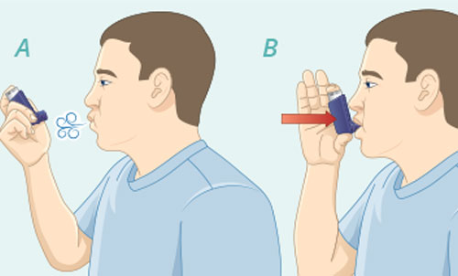
Have person exhale and immediately bring the cannister to the mouth. Have them close lips around mouthpiece.

Have the person breathe in slowly and deeply while the top of the canister is pressed.

Remove mouthpiece and have person hold breath for lupin.com as long as possible, up to 10 seconds or more. Then exhale slowly. Repeat in about a minute if more than one inhalation ordered.

Replace the protective cap and have the person rinse mouth with water and spit it out.

Observe for adverse symptoms.

Remove and dispose of gloves, wash hands. Clean and store equipment.

Document on the MAR that medication was given. If the inhaler was used “as needed”, record the need and the response to treatment.
Dry Powder Inhaler:

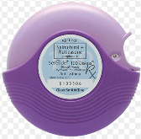
Remove the inhaler cap and load the dry medicine in the inhaler chamber as directed by the manufacturer.

Have the person tilt head back a little and breathe out slowly and completely.

Immediately bring the device to person’s mouth and have them close lips around the mouthpiece. vhv.rs/

Have the person breathe in quickly and deeply for 2 to 3 seconds inhaling the medication form the device.

Remove inhaler from mouth and have the person hold their breath for 10 seconds. Then have them breathe out slowly through pursed lips.

Observe for adverse symptoms.

Remove and dispose of gloves, wash hands. Clean and store equipment.

Document on the MAR that medication was given. If the inhaler was used “as needed”, record the need and the response to treatment.
Second inhaler: If a second inhaler is ordered, wait 5 minutes before giving.

Nebulizer treatment:

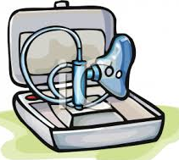
Gather medication and equipment. Check information on MAR and compare with prescription label.

Wash hands and put on gloves. Plug in nebulizer.

Assist person to a comfortable sitting position.

Before placing the pre-measured, ampule dose of medication into the dispensing chamber, check the medication label against the MAR.

Open ampule and instill liquid into the distillation chamber.

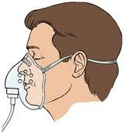
Have the person place the mouthpiece in the mouth, forming a tight seal on the mouthpiece with their lips. (If a mask is being used, make sure it fits well.)

Turn the machine on. Encourage the person to breathe normally during the treatment. Continue the treatment until all medication is given.

Remove mouthpiece or mask. Help the person wipe face, rinse mouth, and apply lip balm if needed.

Clean equipment; return to storage area. Remove and dispose of gloves. Wash hands.

Document that medication was given and any complaints or concerns.

Appendix 6. DOCUMENTATION

tHE MEDICAL RECORD


The Medical Record is a collection of all pertinent facts concerning a person’s medical history.

The Medical Record is confidential and protected under the Health Insurance Portability and Accountability Act (HIPAA). Never share information or discuss an individual with anyone not directly involved in the care of that person.

The Medical Record is an accounting of the person’s condition and care in writing and is signed by the person giving care.

It should always reflect observed facts, NOT opinions or judgements.

The Medication Administration Record (MAR)
The MAR is used to document medications taken by each person.
A MAR includes:

A column that lists the names and dose of medications prescribed.


The times and dates the medication is to be taken.

The initials of the person assisting with the medication.

A start date.

A stop date if known.

Identifying information about the individual, including date of birth, allergies, diagnoses, and names of medical providers.
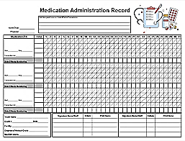

printablee.com

Appendix 7. FILLING OUT THE MAR

Examples of filling out a mar
Example #1:
Carol is having problems with constipation so when she sees Dr. Davis on Monday afternoon, you inform him about this problem. He writes a new prescription which you pick up later that day. You fill out the MAR using the information provided, making sure the prescription and pharmacy information matches.

Davis and Hartman Medical Group, PLLC
1011 Jackson, Helena, MT 59604
406-442-6779

March 2, 2018
Carol Potter Birthdate: 4/10/85

Rx:
MiraLax 17 grams mixed with 8 oz fluid
Sig: give po q am twice weekly
Disp: one-month supply
Refill x 11

Signed: Ron Davis, MD
Ron Davis, MD

Medication = MiraLax and dose (special instructions):
Medication | March | HR | 1 | 2 | 3 | 4 | 5 | 6 | 7 | 8 | 9 | 10
MiraLax 17 grams | start
mixed with
8 ounces of fluid

Route: “po” translates into taken orally or by mouth.
Medication | March | HR | 1 | 2 | 3 | 4 | 5 | 6 | 7 | 8 | 9 | 10
MiraLax 17 grams mixed | start | 7am
with 8 ounces of fluid
by mouth every morning
twice a week

When: “q am” or “every morning” or more accurately in this case “in the morning” of the 2 days each week it is to be given. 7 am is reasonable.

Start date and which days of the week:

The information provided states it is “Monday”.

The medication is to be given in the morning, so the first day given would be the following morning = “Tuesday”.

It is taken twice a week, so Tuesday and Friday are reasonable days.

Block out days: since the prescription was written on Monday, 3/2/18, and the start date is Tuesday, 3/3, block or “X” out the dates before 3/3 and block or “X” out days that are not a Tuesday or a Friday.
- To make it easier, you can make notations of the days of the week on the MAR. Use abbreviations as it is simply a reminder for you.
Medication | March | HR | 1  S | 2  M | 3  T | 4  W | 5  Th | 6  F | 7  S | 8  S | 9  M | 10  T
MiraLax 17 grams mixed | start | 7am | X | X |  | X | X |  | X | X | X
with 8 ounces of fluid | 3/3/18
by mouth every morning
twice a week

The complete MAR appears below. Don’t forget diagnosis and allergies.
Medication | March | HR | 1  S | 2  M | 3  T | 4  W | 5  Th | 6  F | 7  S | 8  S | 9  M | 10  T
MiraLax 17 grams mixed | start | 7am | X | X |  | X | X |  | X | X | X
with 8 ounces of fluid | 3/3/18
by mouth every morning
twice a week

Diagnosis: constipation

Allergies: | None |  | IN | Name: | IN | Name:
Name: | Physician: | Phone # | NR | Noel Ranger | HT | Hillary Thomas
Carol Potter | Ron Davis | 442-6779 | gp | George Peters
DOB: 4/10/85
Example #2:
Brian was seen by Dr. Davis for follow up of atrial fibrillation. Brian’s blood test showed that he needs a change in his warfarin does. His current dose is warfarin 3 mg daily at 2 pm. To fill out the MAR you will need to know that February 6 is a Wednesday. You pick up the prescription at 4 pm and fill out the MAR.
Davis and Hartman Medical Group, PLLC
1011 Jackson, Helena, MT 59604
406-442-6779
February 5, 2018
Name: Brian Hunter DOB: 1/3/40
Rx:
Dose change:
Warfarin 1 mg
Sig: 2 tabs po q 2 pm M, W, F and 3 tabs po q 2 pm S, S, T, Th for
atrial fibrillation. Start tomorrow.
Disp: one-month supply
Refill x 11
Signed: Ron Davis, MD
Ron Davis, MD

Since this is a dose change, you must first cross out the remaining days on the current MAR.

Warfarin is current being taken at 3 mg daily (three 1 mg tablets). The days that he has already taken it are already initialed.

The prescription was picked up at 4 pm and it states to “start tomorrow”, as today’s dose has already been taken.

Since there is a new dose starting on the 6^{th,} which is a Wednesday, all the dates after today are crossed out and a stop date is added.
Medication | Feb | HR | 1 | 2 | 3 | 4 | 5 | 6 | 7 | 8 | 9
Warfarin 1mg 3 tablets | start | 2 pm | ii | ii | ii | ii | ii | X | X | X | X
by mouth daily | 8/4/07
 | stop
 | 2/5/18

Transcribe the new instructions:

There are 2 different doses – which dose depends on the day of the week. Use a separate set of lines for each dose.

Dose #1: “2 tablets po q M, W, F”. This means that two 1 mg tablets are taken each week on Monday, Wednesday, and Friday.

The new dose starts on the day after the prescription was written so that would be 2/6. You were told that 2/6 is a Wednesday so this dosing schedule should be used to start the new prescription.

The days of the week this dose is not given (Saturday, Sunday, Tuesday, or Thursday) should be crossed out.

You were also told that the medication is taken at 2 pm.
Medication | Feb | HR | 1 | 2 | 3 | 4 | 5 | 6 | 7 | 8 | 9 | 10 | 11 | 12
Warfarin 1 mg | start
2 tablets by mouth | 2/6/18 | 2 pm | X | X | X | X | X |  | X |  | X | X |  | X
on Monday, | stop
Wednesday and Friday

It may be easier to fill out and read the MAR if the days of the week are indicated below the date. These notations can be abbreviated.
Medication | Feb | HR | 1 | 2 | 3 | 4 | 5 | 6 | 7 | 8 | 9 | 10 | 11 | 12
Warfarin 1 mg | start |  |  |  |  |  |  | W | Th | F | S | S | M | T
2 tablets by mouth | 2/6/18 | 2 pm | X | X | X | X | X |  | X |  | X | X |  | X
on Monday,
Wednesday and Friday

Dose # 2: “3 tablets po q S, S, T, Th”

The start date for this dose would be 2/7.

All dates prior to 2/7 would be blocked out and any day that isn’t a Saturday, Sunday, Tuesday, or Thursday would be blocked.

Dose # 2: “3 tablets po q S, S, T, Th”

The start date for this dose would be 2/7.

All dates prior to 2/7 would be blocked out and any day that isn’t a Saturday, Sunday, Tuesday, or Thursday would be blocked.
Medication | Feb | HR | 1 | 2 | 3 | 4 | 5 | 6 | 7 | 8 | 9 | 10 | 11 | 12
Warfarin 1 mg, 2 tablets |  |  |  |  |  |  |  | W | Th | F | S | S | M | T
by mouth on Monday, | start | 2pm | X | X | X | X | X |  | X |  | X | X |  | X
Wednesday and | 2/6/18
Friday
Warfarin 1 mg, 3 tablets | start | 2pm | X | X | X | X | X | X |  | X |  |  | X
by mouth on Saturday, | 2/7/18
Sunday, Tuesday,
and Thursday

The compete MAR with diagnosis and allergies is below:
Medication | Feb | HR | 1 | 2 | 3 | 4 | 5 | 6W | 7  Th | 8F | 9  S | 10S | 11M | 12T
Warfarin 1 mg | start | 2pm | ii | ii | ii | ii | ii | X | X | X | X | X | X | X
3 tablets | 8/4/07
by mouth | stop
daily | 2/5/18
Warfarin 1 mg, 2 | start | 2pm | X | X | X | X | X |  | X |  | X | X |  | X
tablets by mouth on | 2/6/18
Monday, Wednesday
and Friday
Warfarin 1 mg, 3 | start | 2pm | X | X | X | X | X | X |  | X |  |  | X
tablets by mouth on | 2/7/18
Saturday, Sunday,
Tuesday and Thursday

Diagnosis: atrial fibrillation

Allergies: | penicillin | IN | Name: | IN | Name:
Brian Hunter | Dr Ron Davis | ii | Ingrid Inez | TJ | Tim Jacobs
DOB: 1/3/40 | Phone: 442-6779 | CP | Carol Peters
Example #3:
Caleb saw Dr. Davis on the afternoon of February 1 for seizures. A new medication, Depakote, was prescribed. You pick up the medication that afternoon. At the group home, after comparing the medication you picked up to your copy of the prescription, you transcribe the new medication onto the MAR.
Davis and Hartman Medical Group, PLLC
1011 Jackson, Helena, MT 59604
406-442-6779
February 1, 2018
Name: Caleb Harris DOB: 1/3/40
Rx:
Depakote 500 mg
Sig: one-tab po q am for 1 week, then BID
Disp: one-month supply
Refill x 11
Signed: Ron Davis, MD
Ron Davis, MD

There is one medication but two dosing schedules which requires using two separates sets of lines on the MAR.

Write out each set of dosing instructions – remember to write out the route and how often it is taken in one day and how long the medication should be taken before stopping it, if known.
Medication | FEB | HR | 1 | 2 | 3 | 4 | 5 | 6 | 7 | 8 | 9 | 10
Depakote 500 mg | start
1 tablet by mouth
every morning for
one week, then
Depakote 500 mg | start
1 tablet by mouth
twice daily

Start date for each dose:

For the first week it is to be given in the morning only, so you would start the new medication the following morning which would be 2/2 as you did not get the medication until the afternoon of 2/1.

Twice daily dose starts 1 week (7 days) later so start date is 2/9.

Write in the hours that it is to be given such as those given below.
Medication | FEB | HR | 1 | 2 | 3 | 4 | 5 | 6 | 7 | 8 | 9 | 10
Depakote 500 mg | start | 7am
1 tablet by mouth | 2/2/18
every morning for
one week, then
Depakote 500 mg | start | 7am
1 tablet by mouth | 2/9/18
twice daily |  | 8pm

Block out the dates prior to the starting dates and after the first week. You can also add a stop date for the first dosing schedule.
Medication | FEB | HR | 1 | 2 | 3 | 4 | 5 | 6 | 7 | 8 | 9 | 10
Depakote 500 mg | start | 7am | X |  |  |  |  |  |  |  | X | X
1 tablet by mouth | 2/2/18
every morning for | stop
one week, then | 2/8/18
Depakote 500 mg | start | 7am | X | X | X | X | X | X | X | X
1 tablet by mouth | 2/9/18
twice daily |  | 8pm | X | X | X | X | X | X | X | X

use of the optional “dot system”
The “dot system” for use on a paper MAR provides an optional means of tracking medications as they are prepared and assists with documentation after administration.
As you check each medication label against the MAR and place the medication into the cup for oral medications, you will place a “dot” in the space on the MAR to mark the spot that you will initial after you administered the medication. The “dot” indicates that the MAR has been checked and the medication is ready for giving. To use the dot system:

As each medication is placed into a cup (for oral medications) and making sure you have the right medication for any other form being administered:

Check the medication label against the MAR.

Check the amount of medication in the cup, etc. to make sure it matches the label and the MAR.

Mark a dot in the space on the MAR where you will initial after you have administered it. The “dot” is a visual assist in identification of the prepared and administered medications. example:
Medication | start | Aug | 1 | 2 | 3 | 4 | 5 | 6 | 7 | 8 | 9 | 10 | 11 | 12
Lisinopril 10 mg | 6/1/17 | 8am | jk | jk | jk | jk | ˖
one tablet by |  |  |  |  |  |  | ↑
mouth daily

Following the administration of the medication(s), you place your initials in the space for that medication documenting that you have given the right medication, the right dose, to the right individual, at the right time, using the right route, the right position, and the right consistency (if indicated).
Medication | start | Aug | 1 | 2 | 3 | 4 | 5 | 6 | 7 | 8 | 9 | 10 | 11 | 12
Lisinopril 10 mg | 6/1/17 | 8 am | jk | jk | jk | jk | NR
one tablet by |  |  |  |  |  |  | ↑
mouth daily

If the medication was prepared but not given, document by initialing the MAR, then circle your initials, and write an explanation.

It is NEVER appropriate to place your initials on the MAR before administering the medication. Documentation of medication administration that has not yet been given compromises the safety of the individual and is falsification of a legal document which is a prosecutable offense.

Appendix 8. MEDICATION ERRORS

When a Medication is TAKEN BY the wrong person, WHICH MEDICATIONS REQUIRE CLOSER MONITORING?
Antipsychotics:
Olanzapine, quetiapine,  risperidone, etc. | All antipsychotics can cause problems depending on dose and the combination with other medications.  Problems associated with antipsychotics include:  - Agitation, alterations in consciousness  - Seizures  - Heart rhythm disturbances  Respiratory depression, aspiration, pneumonia
Clozaril (clozapine) | Clozaril (clozapine) is often said to be the most toxic drug in this class.  Since clozapine lasts a long time in the system, problems can surface, and death can occur well after 6-hours.
Recommendation: | Monitor hourly for at least 24 hours
Antiseizure medications:
Dilantin, Depakote, Phenobarbital, etc. | All anticonvulsants can cause drowsiness, dizziness, heart rhythm disturbances.
Carbamazepine | Carbamazepine is known to interact with other drugs, which can increase its toxicity.
Lamictal (lamotrigine) | Lamictal can cause a severe, life threatening rash especially if a high dose is taken.
Recommendation: | Monitor hourly for at least 24 hours.
Mood stabilizers:
Lithium | Lithium can be very toxic. Since it may take up to 24 hours to distribute into brain tissue, acute toxicity symptoms may be delayed.  Symptoms include:  - Tremor, unstable gait, confusion  - Sedation, abnormal heart rhythms  - GI symptoms of vomiting and diarrhea  - Coma and death
Recommendation: | Monitor hourly for at least 24 hours.
Benzodiazepines:
Especially long-acting benzodiazepines  such as clonazepam, temazepam | Depending on dose and if mixed with other medications can cause drowsiness, dizziness, unsteadiness that can lead to falls, and respiratory depression.
Recommendation: | Monitor hourly for a minimum of 12 hours.
Opioids:
fentanyl, Dilaudid, morphine, oxycodone, methadone | High risk for respiratory depression, sedation, increased fall risk especially long-acting drugs and higher potency ones. Higher risk if mixed with other medications such as benzodiazepines.
Recommendation: | Monitor hourly for at least 24 hours.  Consider obtaining Narcan nasal spray to have on hand for anyone taking chronic opioids.
Antihypertensives:
Especially long acting antihypertensives  Beta blockers  amlodipine (Norvasc)  Some like Clonidine, Inderal, Tenex, and  Prazosin are used for impulsivity and  aggression and not for blood pressure | Most are taken only once daily thus stay in the system longer.  Toxic symptoms include:  - Irregular heartbeat  - Low blood pressure with lightheadedness or fainting  - Shortness of breath  - Changes in heartrate  These are especially concerning if the person taking it by mistake is already taking other heart medications.
Recommendation: | Monitor hourly for at least 24 hours.
Anticoagulants:
Coumadin (warfarin), Xarelto, Eliquis, etc. | Could increase bleeding risk.  Notify medical provider if the person is already taking Coumadin and gets the wrong dose as blood tests may be needed.
Recommendation: | Monitor for falls, other bleeding risks for 12 hours.

Example: Marcy Bender has epilepsy and significant anxiety, especially surrounding visits to the dentist. Marcy was seen on the morning of February 2 and a new medication was prescribed for seizures.
She was also given a prescription for lorazepam to take just prior to her next dental appointment which is scheduled for the morning of February 5.
On February 6, you prepare to assist Marcy with her medications. As you set them up, reviewing the MAR and prescription, you see some errors have occurred. Compare the prescription and the MAR and find at least 5 errors.
Davis and Hartman Medical Group, PLLC
1011 Jackson, Helena, MT 59604
406-442-6779

February 2, 2022
Name: Marcy Bender DOB: 3/7/65
Rx:
Oxcarbazepine 300 mg
Sig: one po BID starting tomorrow
Disp: 60
Refill x 11
Lorazepam 1 mg
Sig: give two tablets po on the morning of 2/5/19
Disp: 2
No refills
Signed: Ron Davis, MD
Ron Davis
Medication Administration Record
Medication | Feb | HR | 1 | 2 | 3 | 4 | 5 | 6 | 7 | 8 | 9 | 10
Oxcarbazepine | start | 7 am | X | X | nr | nr | nr
300 mg | 2/2/22
by mouth BID |  | 8 pm | X | VL | VL | VL | VL
Ativan 1 mg | start | 7 am | X | X | VL | VL
daily | 2/3/22

Diagnosis: seizures, anxiety

Allergies: sulfa |  | IN | Name: | IN | Name:
Marcy Bender | Dr Ron Davis | nr | Nan Rogers | tj | Tim Jacobs
DOB: 3/7/65 | Phone: 442-6779 | cp | Carol Peters | VL | Val Lawry

Answers:
Medication | Feb | HR | 1 | 2 | 3 | 4 | 5 | 6 | 7 | 8 | 9 | 10
Oxcarbazepine | start | 7 am | X | X | nr | nr | nr
300 mg | 2/2/22
by mouth BID 1 | 2 | 8 pm | X | VL | VL | VL | VL
 |  |  |  | 2
Ativan 1 mg | start | 7 am | X | X | VL | VL
daily 3, 4 | 2/3/22 |  |  |  | 5 | 5 | 5
 | 5

Diagnosis: seizures, anxiety

Allergies: sulfa |  | IN | Name: | IN | Name:
Marcy Bender | Dr Ron Davis | nr | Nan Rogers | tj | Tim Jacobs
DOB: 3/7/65 | Phone: 442-6779 | cp | Carol Peters | VL | Val Lawry

BID should be written out as twice daily or two times daily.

Wrong start date: prescription states to start the following morning.

Incorrect directions for the dose: should say two tablets on 2/5.

Does not have directions: should say by mouth or orally, etc.

Wrong start date: should be 2/5 when 2 tablets were supposed to be given.
The correct MAR appears as follows
Medication | Feb | HR | 1 | 2 | 3 | 4 | 5 | 6 | 7 | 8 | 9 | 10
Oxcarbazepine | start | 7 am | X | X | nr | nr | nr
300 mg | 2/3/22
by mouth |  | 8 pm | X | X | VL | VL | VL
twice daily
Ativan 1 mg | start | 7 am | X | X | X | X | nr | X | X | X | X | X
two tablets by mouth | 2/5/22
on the morning of
2/5/22

Diagnosis: seizures, anxiety

Allergies: sulfa |  | IN | Name: | IN | Name:
Marcy Bender | Dr Ron Davis | nr | Nan Rogers | tj | Tim Jacobs
DOB: 3/7/65 | Phone: 442-6779 | cp | Carol Peters | VL | Val Lawry

Appendix 9. TYPES/CATEGORIES OF MEDICATIONS

anti-infective medications
- The body’s natural defenses can help fight infections without treatment.
- When a drug is needed, remember that no one drug is effective for all infections.
- Anti-infective drugs often simply hold the infection in check long enough for the body’s defenses to gear up and kill the organism.
- Anti-infective drugs work against different infecting organisms.
- A drug that is effective against bacteria will not work on viruses or fungi. An infection such as pneumonia can be caused by bacteria and then an antibiotic will help. But pneumonia can be caused by viruses, too and then an antibiotic will not help.


Bacterial infections:

Respiratory infections:
- Upper respiratory infections: sinusitis and sore throat.


NOTE: most upper respiratory infections are caused by viruses, so antibiotics have NO effect on them.
- Otitis media (ear infection).
- Lower respiratory infections such as pneumonia and bronchitis.

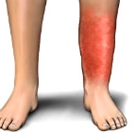
Skin infections:
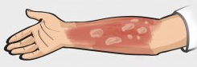
- Boils, cellulitis, impetigo, complications from burns.

www.sepsis.org
- Infections in wounds after surgery.

Gastrointestinal infections: www.drugs.com

- Infectious diarrhea from Salmonella, shigella, E. coli, Campylobacter, and C. difficile.
- Helicobacter pylori which can cause gastritis and peptic ulcers.


Genitourinary infections:
- Urinary tract infections (UTI) – bladder infection.
- Prostatitis – infection in the prostate gland.
- Bacterial vaginosis.

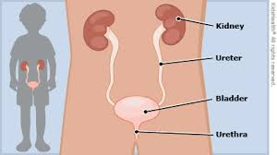

- Pyelonephritis – bacteria enter the bladder and travel up the ureter to the kidney causing an infection.

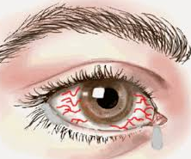
Others:
- Heart – endocarditis.
- Meningitis – infection in fluid surrounding
the spinal cord and brain.
- Blood infections – septicemia.
- Eye infections.

Viral infections:

Viruses usually infect one particular type of cell and must invade a living cell in order to grow. For example, cold viruses infect only cells of the upper respiratory tract.

Upper respiratory infections:
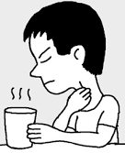
- Common cold
- Sore throat
- sinusitis
- Influenza

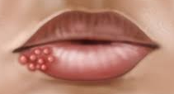
Skin infections:
- Warts
- Herpes simplex – cold sores, genital herpes
- Herpes zoster – shingles

Brain and spinal cord:
- West Nile
- Rabies
- Viral encephalitis

Other:
- Mononucleosis – Epstein-Barr virus


powerofpositivity.com

Appendix 10. MEDICATIONS FOR PSYCHIATRIC CONDITIONS

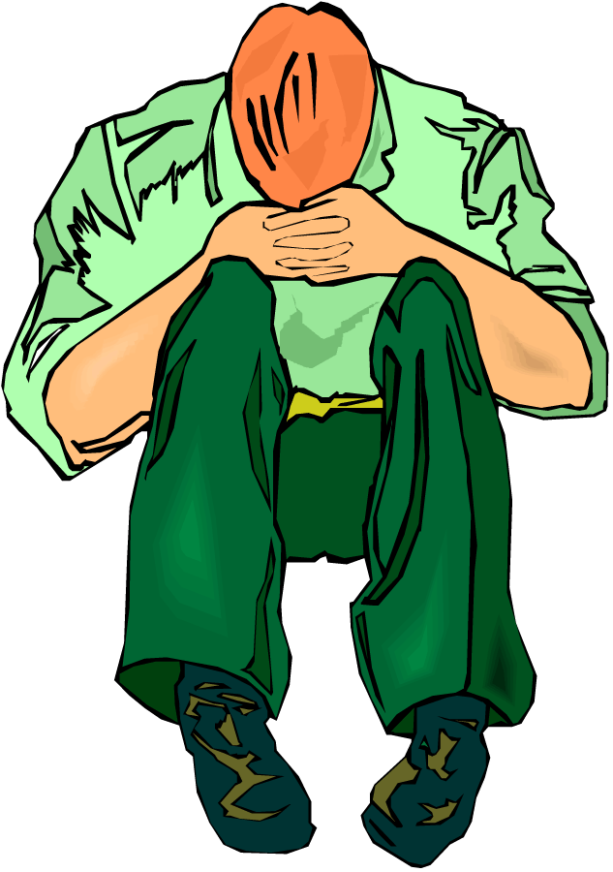
DEPRESSION AND ANTIDEPRESSANTS

Clinical depression goes beyond everyday sadness.

Symptoms of depression include:

Depressed mood – people tend to feel:
- Sad, blue, or “down in the dumps”.
- Discouraged, hopeless.
- Angry, frustrated, irritable, annoyed.
- May describe themselves as having “no feelings” or feeling “blah”.


Loss of interest or pleasure in most or all activities.

Change in appetite or weight.

Insomnia or hypersomnia - sleeping too little or too much.

Feelings of worthlessness or excessive guilt.

Fatigue, loss of energy, poor concentration, memory problems.

Psychomotor agitation or retardation (restlessness or sluggishness).


Recurrent thoughts of death or suicide.

Seasonal Affective Disorder (SAD):

Depression that comes and goes during certain times of the year.

The most common form starts in late fall; goes away in spring/summer. https://www.freepik.com/

Bright light therapy often used to treat, with or without antidepressants.

Bipolar Disorder (Manic depression):


Moods can range from mania to depression.

Mania – symptoms generally last about a week but some people cycle quickly.
- People usually feel abnormally and persistently happy, angry, hyperactive, impulsive, and irrational at times.
- Other symptoms include:

Feelings of special powers and superiority.

Decreased need for sleep, restlessness, increased activity.

Talking excessively, racing thoughts; short attention span.

Inappropriate spending sprees or sexual activity.

Hypomania – less severe than mania but causes a change in mood that is abnormal. Usually lasts at least 4 days.

Antidepressants:

Antidepressants will often take 3 to 5 weeks to have a noticeable effect as the regulation of receptors in the brain adapt.

Classes of antidepressant drugs include:
- Selective serotonin uptake inhibitors (SSRIs).
- Serotonin-norepinephrine reuptake inhibitors (SNRIs).
- Tricyclic antidepressants (TCAs).
- Norepinephrine-dopamine reuptake inhibitor (NDRI).
- Noradrenergic and specific serotonergic antidepressant (NaSSA).
- Serotonin antagonist and reuptake inhibitor (SARI)
- Monoamine oxidase inhibitors (MAOIs).


NOTE: anyone taking oral MAOIs must avoid certain foods that contain tyramine due to the risk of developing severely elevated blood pressure. Foods and beverages include fermented cheese, imported beer, some wines, soy sauce, avocados, bananas, and any fermented, smoked, or aged fish or meat. Of note, the selegilene patch (EMSAM) does not require dietary modification at the usual dosing.

Other treatments for depression:

Psychotherapy – many types exist and each works in a slightly different way, but all have been proven to help improve symptoms.

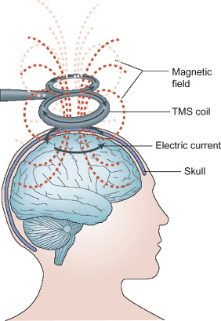
Devices that stimulate the brain – called neuromodulation interventions are used to treat drug-resistant depression.
- Transcranial magnetic stimulation (TMS) – involves placing a device against the scalp to pass magnetic waves into the brain.
- Electroconvulsive therapy (ECT) – involves passing an electric current through the brain while the person is under general anesthesia. This results in a seizure causing chemical changes in the brain that can relieve severe depression. Sciencedirect.com

Ketamine
- Anesthetic drug, usually given by IV.
- Used for analgesia and sedation
- Has been found to alleviate depression rapidly and transiently.
Medication: | Side effects (not limited to those listed)
SSRIs: fluoxetine (Prozac®), sertraline  (Zoloft®), fluvoxamine (Luvox®), paroxetine (Paxil®), citalopram (Celexa®), escitalopram (Lexapro®) | jitteriness, restlessness, agitation  insomnia, headache,  nausea, diarrhea  sexual side effects
SNRIs: duloxetine (Cymbalta®), venlafaxine (Effexor®) | nausea, constipation, dizziness, sedation, insomnia
TCAs: amitriptyline, doxepin, imipramine, nortriptyline | dry mouth, constipation, nausea, drowsiness, weight gain
NDRI: Bupropion (Wellbutrin®) | anxiety, insomnia, loss of appetite, seizures
NaSSA: Mirtazapine (Remeron®) | sedation, increased appetite, weight gain, dry mouth
MAOIs: tranylcypromine (Parnate®)  isocarboxazid (Marplan®),  phenelzine (Nardil®) | dizziness, dry mouth, GI upset  headache, fatigue
SARI: trazodone (Desyrel®) | sedation, nausea, lightheadedness

Antidepressant medications and side effects

antipsychotic agents

Adverse effects of antipsychotic medications
Medication: | Adverse effects:
Aripiprazole  (Abilify®) | Mild weight gain/diabetes, mild sedation, mild risk for EPS/TD. Also, headache, nausea, constipation
Asenapine  (Saphris®) | Mild to moderate risk for weight gain/diabetes, EPS/TD, prolactin elevation, and sedation
Brexpiprazole  (Rexulti®) | Mild risk for weight gain/diabetes, EPS/TD, and sedation. Also, headache, hyperhidrosis (sweating), dyspepsia
Cariprazine  (Vraylar®) | Mild risk for EPS, headache, insomnia, and nausea
Clozapine  (Clozaril®) | High risk for weight gain/diabetes, anticholinergic side effects, and hypercholesterolemia. Moderate risk for orthostatic hypotension, sedation. Can also cause a low white blood cell counts thus requires regular monitoring.
Iloperidone  (Fanapt®) | Moderate risk for orthostatic hypotension, mild to moderate risk for weight gain/diabetes and hypercholesterolemia. Also, elevated heart rate, dizziness, drowsiness.
Lumateperone  (Caplyta®) | Moderate risk for drowsiness, headache, sedation. Low risk for nausea, dizziness. May cause increased liver tests, cholesterol, and creatine phosphate level.
Lurasidone  (Latuda®) | Mild to moderate risk for EPS/TD and sedation, mild risk for orthostatic hypotension. Also, nausea, drowsiness, insomnia
Medication: | Adverse Effects:
Olanzapine  (Zyprexa®) | High risk for weight gain/diabetes and hypercholesterolemia. Mild to Moderate risk for sedation and anticholinergic side effects.
Paliperidone  (Invega®) | Moderate risk for weight gain/diabetes, EPS/TD, prolactin elevation Mild to moderate risk for orthostatic hypotension
Pimavanserin  (Nuplazid®) | Mild to moderate risk for orthostatic hypotension, mild risk for weight gain/diabetes, sedation, anticholinergic side effects
Quetiapine  (Seroquel®) | Moderate risk: weight gain/diabetes, hypercholesterolemia  Mild to moderate risk: anticholinergic side effects, orthostatic hypotension, and cardiac arrhythmias
Risperidone  (Risperdal®) | Moderate risk for weight gain/diabetes, EPS/TD, prolactin elevation.  Mild to moderate risk for cardiac arrhythmias
Ziprasidone  (Geodon®) | Moderate risk for cardiac arrhythmias  Mild risk for EPS/TD, prolactin elevation, and sedation

Note: the medications listed are the ones in use at the time of publication, new medications are being released each year.

Appendix 11. SEIZURE DISORDERS
More Symptoms of Focal Motor Seizures

Automatisms
- Head nodding
- Tapping, manipulating, exploring movement with the hands
- Orofacial: lip smacking or pursing, chewing, swallowing, clicking, eye-blinking
- Pedaling, walking, running movements
- Undressing. Sexual behaviors: such as pelvic thrusting
- Perseveration: inappropriate continuation of pre-seizure movement
- Vocalization: single or repetitive sounds such as shrieks or grunts
- Speech: single or repetitive words, phrases, or sentences
Motor
- Dysarthria: slurred or slow speech
- Dystonic: muscles contract uncontrollably causing body to twist
- Incoordination: cannot use parts of the body together smoothly
- Paresis/paralysis: weakness or complete inability to move muscles
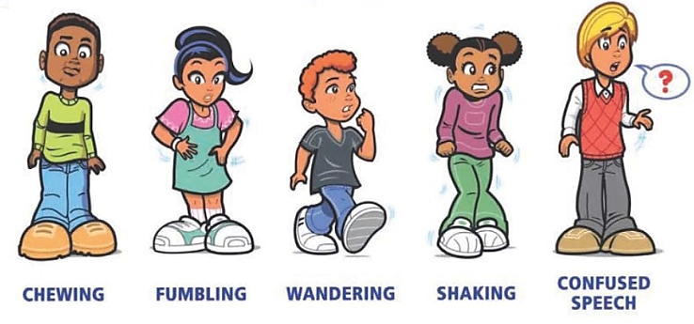
https://www.ventureacademyca.org/seizure-disorders-at-school.html

Drugs Used in the Treatment of Seizures*
Drugs used to treat both focal and generalized seizures
Brivaracetam (Briviact®) | Perampanel (Fycompa®)
Clobazam (Onfi®) | Phenobarbital
Felbamate (Felbatol®) | Topiramate (Topamax®)
Lacosamide (Vimpat®) | Valproate (Depakote®)
Lamotrigine (Lamictal®) | Zonisamide (Zonegrin®)
Levetiracetam (Keppra®)
Benzodiazepines:  Clonazepam (Klonopin®) | Diazepam (Valium®)  Lorazepam (Ativan®)
Drugs used primarily for focal seizures
Carbamazepine (Tegretol®) | Oxcarbazepine (Trileptal®)
Cenobamate (Xcopri®) | Phenytoin (Dilantin®)
Eslicarbazepine (Aptiom®) | Pregabalin (Lyrica®)
Ezogabine (Potiga®) | Tiagabine (Gabitril®)
Gabapentin (Neurontin®)

Ethosuximide (Zarontin®): used for absence seizure only.
Rufinamide (Banzel®) used in treatment of Lennox-Gastaut Syndrome.
*Listed are the drugs available at the time of publication. New drugs are appearing regularly.

Side effects of anti-seizure medications

Systemic side effects:
- Nausea, vomiting, abdominal pain, constipation, anorexia.
- Weight gain, weight loss, fatigue, inability to sweat.
- Hyponatremia, elevated liver tests, elevated ammonia level.


Neurologic side effects:
- Headache, blurred vision, double vision.
- Dizziness, ataxia, tremor; anxiety, depression.
- Irritability, aggression, hyperactivity.

SPECIFIC SIDE EFFECTS OF SEIZURE MEDICATIONS:
Drug | Systemic side effects | Neurologic side effects
Brivaracetam (Briviact®) | nausea, vomiting, constipation, fatigue | headache, somnolence, ataxia, dizziness, nystagmus
Cannabidiol | anorexia, anemia, rash, diarrhea, high liver tests | drowsiness, lethargy, malaise, sleep disturbance, insomnia
Carbamazepine (Tegretol®) | nausea, diarrhea, hyponatremia, rash, itching | drowsiness, blurred vision, lethargy, headache, dizziness
Cenobamate  (Xcopri®) | Elevated potassium, double vision, nausea, constipation, diarrhea, dry mouth, heartburn | Drowsiness, fatigue, headache, lethargy
Clobazam (Onfi®) | drooling, nausea, constipation | irritability, aggression, insomnia
Eslicarbazepine (Aptiom®) | nausea, rash, diarrhea | dizziness, drowsiness, tremor, headache, double vision, ataxia
Ethosuximide (Zarontin®) | nausea | drowsiness, hyperactivity
Felbamate (Felbatol®) | nausea, wt. loss, anorexia | dizziness, insomnia, ataxia,
Gabapentin (Neurontin®) | nausea, fatigue | dizziness, ataxia
Lacosamide (Vimpat®) | nausea, fatigue | ataxia, dizziness, double vision
Lamotrigine (Lamictal®) | rash, nausea, headache, fever, chills, conjunctivitis | dizziness, tremor, double vision
Levetiracetam (Keppra®) | infection, fatigue | agitation, sleepiness, dizziness, irritability, anxiety, depression
Oxcarbazepine (Trileptal®) | nausea, rash, hyponatremia | sedation, headache, dizziness
Perampanel (Fycompa®) | nausea, weight gain | dizziness, aggression, irritability
Phenobarbital (Sezaby®) | nausea, rash | sedation, lethargy, hyperactivity
Phenytoin (Dilantin®) | gingival hypertrophy, rash | confused, slurred speech, ataxia
Pregabalin (Lyrica®) | weight gain, dry mouth | dizziness, sleepiness, tremor
Rufinamide (Banzel®) | nausea, fatigue | dizziness, headache, sleepy
Tiagabine (Gabitril®) | abdominal pain, nausea | dizziness, sleepy, tremor
Topiramate (Topamax®) | weight loss, tingling, fatigue, anorexia. Inability to sweat | depression, confusion, tremor, problems finding words, anxiety
Valproate (Depakote®) | weight gain, high ammonia | tremor dizziness
Vigabatrin (Sabril®) | vision loss, fatigue | drowsiness, dizziness
Zonisamide (Zonegrin®) | nausea, loss of appetite | sleepy, dizziness, confusion
The most common side effects are listed; this is not a complete list. The drugs listed are those available at the time of publication. New drugs are being released regularly.

PRN Treatment for Seizures/Status Epilepticus

Nasal Medications

Midazolam:
- Midazolam, administered via the intranasal route, can stop seizure activity. A prescription and protocol are required for its use.
- A special nasal atomizer attached to a syringe containing the medication is used. See information below on the commercially available ready-to-use nasal spray device (Nayzilam Nasal®).
- This method of delivery is:

easy to use

can be delivered from any position

takes very little time

does not require restraint of the person
- The drug is highly concentrated so only a small amount is used.

Steps for administration of nasal midazolam:

Assess ABC’s – Airway, Breathing, Circulation.
- If no pulse or breathing, proceed to CPR and call 911; otherwise:

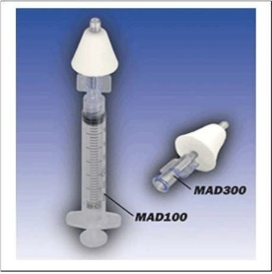
Put on gloves. Attach the nasal atomizer tip to the syringe containing midazolam – twist into place. If you have a prefilled syringe, remove the cap by twisting off first.

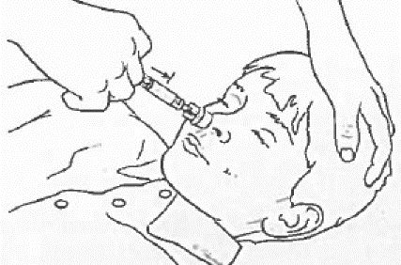
Using your free hand to hold the crown of the head stable, place the tip of the atomizer snugly against the nostril aiming slightly up and outwards (towards the top of the ear).

Briskly compress the syringe plunger to deliver half of the medication into the nostril. (Or use a second syringe for the second half of the dose.)

Move the device over to the other nostril (or attach the nasal atomizer to the second syringe) and administer the second half of the dose.

Place the person on their side and monitor for ongoing seizure activity and signs of breathing problems.
Clip art obtained from Ohio DDD med manual

Procedure for drawing up midazolam from a vial (bottle):

Pull the plunger of the syringe back until the black seal is at the appropriate mark on your syringe.

For example, if you are to draw up 1.0 ml of medication, pull the plunger back to the 1 ml mark on the syringe. The syringe will now have 1 ml of air within it.

Pop protective plastic cap off the vial of midazolam.

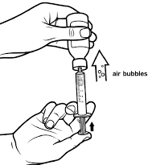
Connect the syringe (twist or slip) to the needle or needleless access device and puncture the rubber seal.

Tip the vial up-side down so the syringe is on the bottom and the vial’s rubber seal faces down.

Compress the syringe plunger, injecting air.

Pull the plunger back and allow the syringe to fill with medication (look inside the vial to see that the tip of the needles is within the liquid, otherwise you will just draw the air back out). Draw up the proper volume.

Remove the syringe from the vial. Twist off/remove the syringe from the needle or needleless device. It is now ready for the atomizer to be attached.

Nayzilam Nasal®
- Nayzilam® is a commercially available ready-to-use nasal spray device that contains 5 mg midazolam in 0.1 ml solution. The person must have a prescription and protocol for its use.
- It is indicated for use with seizure clusters.
- It is easy to use but quite expensive.
- Steps to administer:

Peel open blister pack, remove nasal spray unit carefully. There is one dose of midazolam in the spray unit. Put on gloves.

Hold the nasal spray device with your thumb on the plunger and your middle and index fingers on each side of the nozzle.

Place the tip of the nozzle into one nostril until your fingers are against the bottom of the person’s nose.

Press the plunger firmly. Remove nozzle from the nostril after giving the dose. Dispose of spray unit, blister pack and gloves.
Drawings obtained from www.ucb-usa.com/nayzilam-instruction.pdf and bayerhealthcare.net

Valtoco® (intranasal diazepam)
- Valtoco is a commercially available ready-to-use nasal spray device that contains 5 mg, 7.5 mg, or 10 mg of diazepam.
- Treatment doses are 5 mg, 10 mg, 15 mg, or 20 mg depending on the person’s age and weight.
- A prescription and protocol must be in place for use.
- Steps to administer:
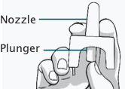 | 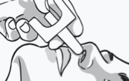 | 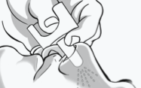
1. Hold with your thumb on the bottom of the plunger and your first and middle fingers on either side of the nozzle | 2. Insert the tip of the nozzle into 1 nostril until your fingers, on either side of the nozzle, are against the bottom of the person’s nose. | 3. Press the bottom of the plunger firmly with your thumb to give Valtoco. Throw away nasal spray device after use.

https://www.valtocohcp.com/

If giving the 15 mg or 20 mg dose, steps one through 3 will be repeated with a second device in the other nostril.

A second dose may be given at least 4 hours after the initial dose according to protocol.

Oral Routes
- Midazolam and lorazepam can be given through an oral route.
- Neither is effective if swallowed as it takes too long to absorb.
- Medications are given through the buccal route or sublingually.

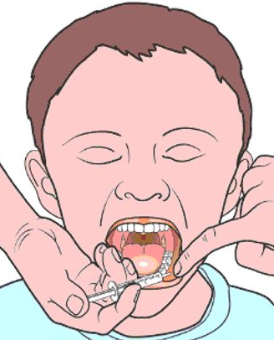
Procedure for giving BUCCAL lorazepam or midazolam syrup:

The amount of lorazepam or midazolam to be given will be determined by the medical provider. An order is required, and a protocol should be in place.

Put on gloves and draw up the desired amount into a syringe.

retainskills.com/buccal midazolam
If the person is in a chair:

Make sure the head is supported. This can be done by standing behind the person and holding his chin being careful not to press on the throat.

Open the mouth gently by holding the chin, apply downward pressure on the lower lip and wipe away excess saliva.

Place the syringe between the lower gum and cheek on one side of mouth; slowly give half the medication in the syringe.

Remove the syringe, close mouth, and rub the cheek on the outside.

Repeat this on the other side.

Place person on side; monitor for seizure activity or breathing problems.
If the person is on the floor:

Hold chin to keep the head steady; turn head to one side.

Open mouth gently by holding the chin while applying downward pressure on the lower lip. Wipe away excess saliva.

Place the syringe between the lower gum and cheek on one side and slowly give half the medication.

Remove syringe, close mouth, and rub cheek on the outside.

Repeat this on the other side of the mouth to give the rest of the medication.

Do not give syrup too quickly to avoid choking.

Place person on side; monitor for seizure activity or breathing problems.

Clip art taken from https://www.uwhealth.org/healthfacts/parenting/7212.pdf

Procedure for giving SUBLINGUAL lorazepam tablets

The dose and frequency of use will be determined by the medical provider. A prescription and protocol should be in place.

The tablet will go on the inner side of the lower lip or inside the cheek area.
- Prior to placing the tablet, wipe the area dry to avoid losing the medication if the www.zubsolv.com person is drooling.
- Avoid placing the tablet near the back of the mouth as it could then be swallowed and thus not work as quickly.
- Do not attempt to place the tablet under the tongue as the teeth may be clenched during a seizure.
- Do not restrain the person when giving the medication.

Gently massage the skin over the area the tablet was placed until it is dissolved. This should take 30 to 60 seconds.

Rectal Route:

Diazepam (Valium®) is available as a rectal gel. It goes by the brand name of Diastat®.

It requires a medical provider’s prescription, and a protocol should be in place for its use.

Diastat® is less effective than intranasal therapy.

It is NOT a suppository; it comes in a rectal syringe in gel form.

It is packaged premixed and premeasured:
- The range of dosing is from 5 to 20 mg
- The dose will be determined by the medical provider.
- The pharmacist will “dial in” the correct dose on the pre-filled syringe and lock it into place.
- A green “READY” band should be visible when the unit is locked.
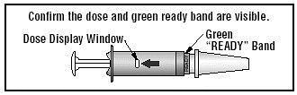

Ohio DDD med manual

Procedure for giving rectal Diastat®

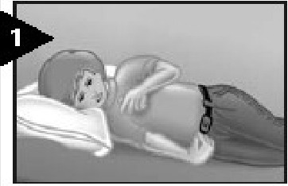
Get the Diastat® kit and put on gloves.

Turn the person on his/her side making sure the person cannot fall or be injured on anything in the area.

Take out the syringe. Note: The Seal Pin is attached to the cap.

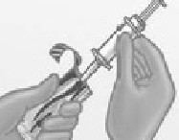
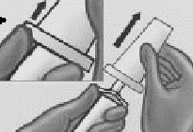
Push up with thumb and pull to remove cap from syringe. Make sure the Seal Pin is removed with the cap.

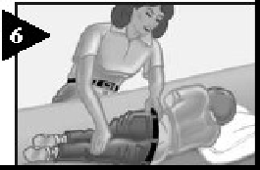
Put lubricating jelly on the tip of the syringe.

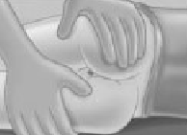
Turn person on side facing you.

Remove clothing from lower body.

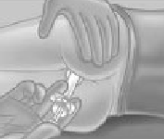
Bend upper leg forward to expose anus.

Gently insert syringe tip into the rectum with the rim snug against the anal opening. Slowly count to three while gently pushing plunger in until it stops.

Slowly count to three before removing the syringe tip from the rectum.

Slowly count to three while holding the buttocks together to prevent leakage.

Keep person on side and monitor. Note the time it takes for the medication to work and seizure activity to stop.
Clip art taken from Ohio DDD med manual

Deaths related to epilepsy

The risk for death is 3 times higher with epilepsy and can be due to:
- Status epilepticus.
- Aspiration pneumonia or head injury.
- Drowning, which can occur in as little as a few inches of water.
- Surgical and medical treatments for epilepsy.
- Sudden and unexpected death in epilepsy (SUDEP).

SUDDEN AND UNEXPECTED DEATH IN EPILEPSY (SUDEP)

Definition: SUDEP is defined specifically as the sudden, unexpected, witnessed, or unwitnessed, nontraumatic and non-drowning death in someone with epilepsy with or without evidence for a seizure, and excluding documented status epilepticus, in which postmortem examination does not reveal a structural or toxicologic cause for death.

The cause is uncertain but may be due to:
- Cardiac rhythm problems – the heart beats too fast or too slow.
- Central apnea (the brain causes the person to stop breathing).
- Spasm of larynx which blocks air passage.
- Neurological injury causing the lungs and heart to stop working.

Risk factors include:
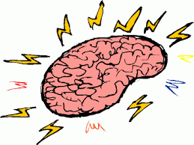
- Early age of developing epilepsy.
- Frequent generalized seizures/poorly controlled seizures.
- Seizures that are very difficult to control.
- Living and/or sleeping alone.

Prevention:
- Identify individuals at risk.

Mostly affects younger adults.


Those with Dravet’s Syndrome and Lennox Gastaut Syndrome are at a higher risk.
- Control generalized seizures.

Optimize seizure medications, especially adherence to taking them.


- Try to determine what precipitates seizures.

Optimize sleep, etc.
- Address comorbidities.
- Use precautions to monitor the individual, such as regular checks throughout the day and night.



Regular checks during the day

Nighttime supervision as most SUDEP occurs at night.

Explore the use of monitoring devices.
- Discuss the role of surgery and VNS units with medical provider.


Mortality from SUDEP decreases by about a third after surgery.

2 years after VNS placement, the risk for SUDEP drops substantially.

Appendix 12. STROKES

strokes
There are two main types of strokes.

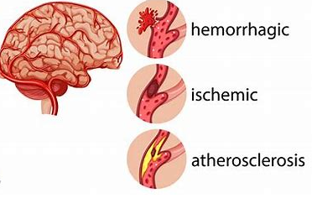
Ischemic strokes:

From blockage of blood vessels.

Most are of this type.

Types of ischemic strokes:
- Thrombotic stroke: a blood clot forms in artery due to atherosclerosis (cholesterol plaques).
vecteezy.com

- Embolic stroke: a piece of blood clot (embolus) formed elsewhere breaks off and becomes lodged in an artery.

Hemorrhagic strokes:

Caused by bleeding in the brain, often due to an aneurysm.

This type of stroke occurs when a blood vessel in the brain leaks or ruptures causing bleeding in or around the brain.

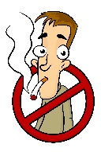
Prevention

Control risk factors.


Make lifestyle changes:
- Smoking cessation.
- Cutting back on alcohol.
- Eating healthy.
- Exercising regularly.

Risk factors

Risk factors for TIA’s and ischemic strokes:

- Age over 40 years.
- Heart disease (atrial fibrillation, carotid stenosis).
- Hypertension.
- Smoking.
- Diabetes.
- Elevated cholesterol.
- Illegal drug use or heavy alcohol use.
- Recent childbirth.
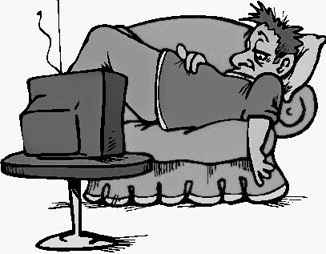
- Previous history of TIA.
- Sedentary lifestyle and lack of exercise.
- Obesity.
- Current or history of blood clots.
- Family history of heart disease or stroke.
- History of migraines with aura.

Risk factors for TIA’s and hemorrhagic strokes:

- Hypertension.
- Smoking.
- Illegal drug use (especially cocaine or “crystal meth”).
- Use of warfarin or other anticoagulants.

Clipart images in Section 3A, except where indicated, were obtained from clipart-library.com.

